New or Changed Functionality or User Experience

New Page Editing
Classic Page Editing will be removed from sites and replaced with our New Page Editing with the July release, currently scheduled for July 28, 2020. That’s a tentative date and could change, so be sure to watch our release notes for updated information as we have it! There’s nothing you’ll need to do to enable it, the transition will happen automatically with the update. Please contact support if you have any questions!

New Site Manager design
Our Site Manager interface is getting a face-lift! We’re excited to launch a new Site Manager Ultra design! All the administrative tools, reports, and content apps remain the same, but we’ve updated the look and feel to be more user-friendly. It’s a big change, we know, so we’re giving you lots of time to get ready for it. You can choose to move to the new Ultra interface or keep the current interface until July 2020.

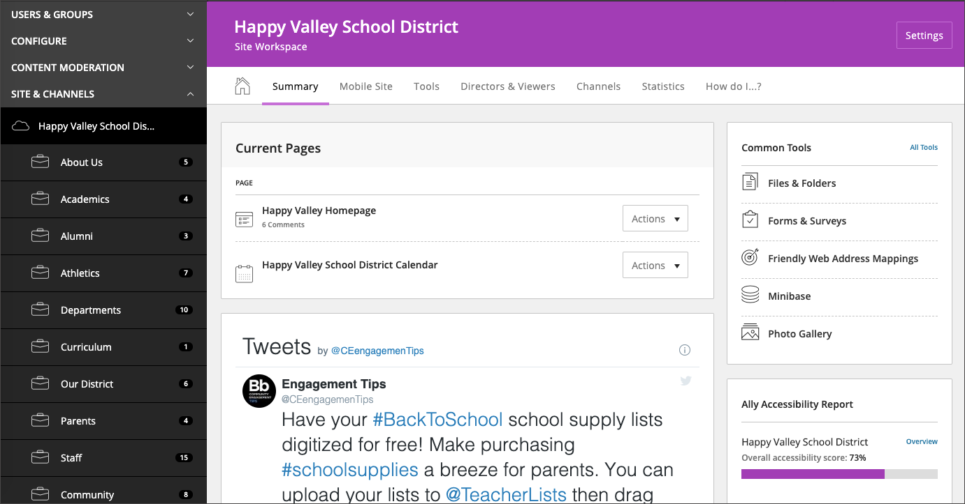

Ready to try it out? Navigate to System Settings in Site Manager and select Enable Site Manager Ultra Styling!

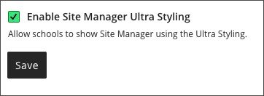

Design Ready Templates
Our Design Ready Templates require updates when defects are found, accessibility guidelines change, new WCM features change, etc. We've made it easier for you to keep track of updates with our subscription service. When an update has been applied to a Design Ready Template that you have subscribed to, you receive an email with the release information. You can review the release information before clicking the "Update" button for the template.

Subscribe to template updates

Resolved Issues
We have resolved the following issues in this release. We’ve listed the issues as they were originally entered and in the order that they were reported.
Functional Area | Subject
Files & Folders | Files in sections deleted from the recycle bin were still available
Staff Directory | Thumbnail images being flagged as null
General | Performance enhancement

Technical Requirements
Here are the Web Community Manger End-User Technical Requirements.
The Blackboard Privacy Policy updated to reflect the Blackboard brand.

Refresh Your Cache
It's always a good practice to clear your browser cache on a regular basis. Refresh your Cache shows you how to clear your cache in any browser.

Resources and Materials
As always, you can find resources and materials related to this release as well as to the many features and functions on the Blackboard Help website. Core Resources and Hot Help Topics, Apps Showroom, Training and Creative—we’ve got the information you need to succeed with your Web Community Manager website.

