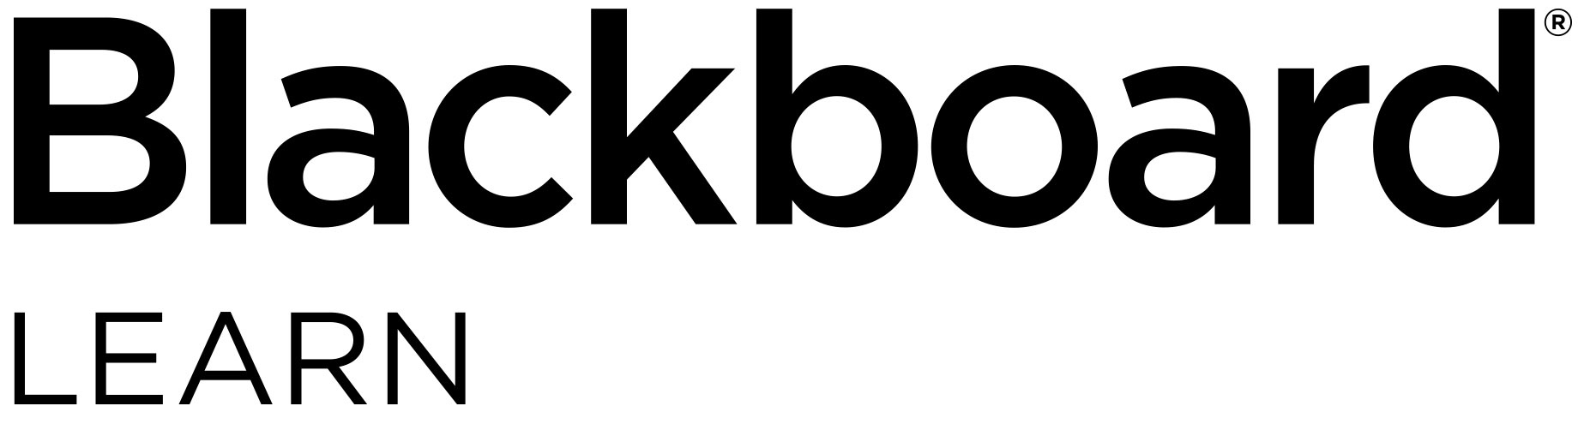

Educators: Check out what’s new for

Blackboard Learn

Overview of th

e newest features and enhancements

**The following new features and enhancements were made available in 2019.**

Efficiency and Engagement

* Open file upload warning for Edge browser users – If you or your students are Microsoft Edge browser users, you might have encountered problems attaching and submitting open Microsoft Office files. To compensate for this known Microsoft Edge issue, we have created a prompt in Learn reminding users to close files before uploading them.
* Course availability controls now in more places – You’ll now have access to the popular course availability indicator and toggle control for courses from additional tools and management pages, like the Discussion Board page.
* Calendar items and due date notifications for additional content types – You and your students will have a more comprehensive view of all class requirements and activities as the Calendar and To Do modules now include the due dates from additional content types: manual columns, SCORM, and third-party solutions.
* New Facilitator course role and more granular permissions – For institutions that centrally manage course development and settings, these more granular course role permissions enable roles to teach, engage, and grade, but not modify materials or settings. There is also a new default course role called Facilitator.
* Blackboard CollaborateTM attendance integration – When hosting Collaborate sessions, taking attendance is now automated, eliminating the need for manual tracking. Collaborate session attendance is recorded within the Attendance page of the Learn course, is counted in the average attendance calculation, and can be factored into students’ grades.
* Content Collection updates – To improve the performance and usability of the Content Collection, files uploaded as part of a SCORM package are now shown in the Content Collection folder. When versioned files are imported/restored, the version number is indicated in the file name.

Assessment and Grading

* Grade Center improvements on desktop – For institutions using the Learn 2016 Theme, the cell padding in the Grade Center for desktop users has been decreased so that more Grade Center data will display.
* Grade Center improvements on mobile devices – To increase your efficiency on mobile devices, the behavior, display, and actions of the Grade Center’s mobile card view are now more consistent with the grid view for institutions using the Learn 2016 Theme.
* Needs Grading filter selection is remembered Your “Show attempts that don’t contribute to user’s grade” filter preference on the Needs Grading page will now be remembered across all your sessions and courses.
* New SafeAssign Originality Report – The SafeAssign Originality Report has been updated and reformatted for improved usability, responsiveness, and accessibility. It employs Blackboard’s Ultra design philosophy and includes new information about the overall risk of a submission having been copied.
* Improved Grades Journey support for merged courses – Institutions using merged courses can now more readily use all the capabilities of Grades Journey.

**Standards and Interoperability**

To ensure you’re able to integrate your portfolio of solutions with Blackboard Learn in a deep, rich, and consistent way, we continue to invest significantly in building more REST APIs and supporting IMS standards, including Learning Tools Interoperability (LTI) and Questions and Test Interoperability (QTI).

* LTI Advantage certified and in production Blackboard Learn is the first major LMS to make LTI Advantage available. [LTI Advantage](https://www.imsglobal.org/lti-advantage-overview) is the latest in interoperability standards for integrating tools into a learning environment. It allows for deeper, richer, and more consistent and secure integrations than previous LTI versions.
* LTI Assignment and Grades Service – When a tool implements the LTI grading and submission state, you’ll now be able to see which students have submitted, including in the Needs Grading workflow, and whether grading has started. Your students will have more accurate due and overdue notifications because their submissions will register with Blackboard Learn even if the submission requires grading before a score is sent to the grade book.
* LTI Context Membership Service – For some time, tools using the Names and Roles Provisioning Service have been able to request a list of students in a class. Now using this extension, tools can also request group definition and group membership data so you won’t have to set up your groups again.
* Support for IMS Global’s Questions and Test Interoperability (QTI) specification – To simplify your online management of assessment, you are now able to add and export Learn question pools as QTI packages.

**The latest releases for the Original experience of Blackboard Learn include new features and enhancements that:**

Save time by improving the efficiency and ease of use of completing your daily tasks

Ensure your courses are engaging, accessible to all, and mobile friendly

Simplify and enhance the assessment and grading capabilities

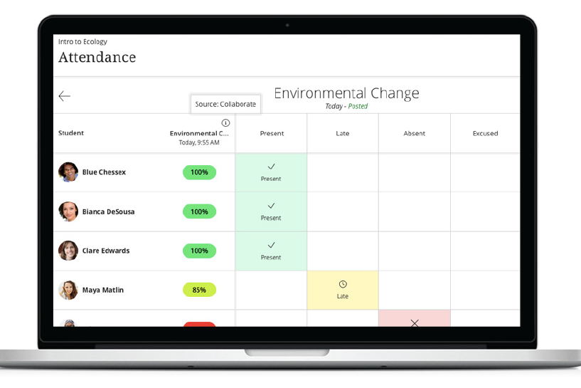

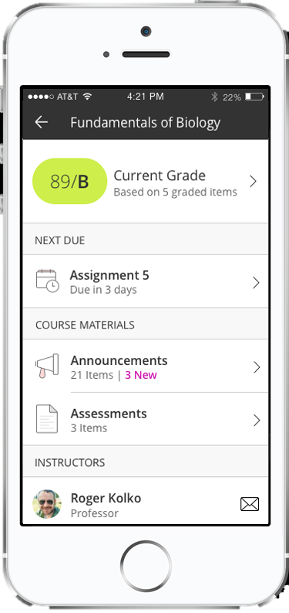

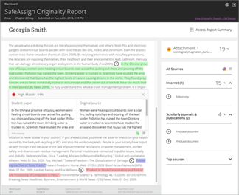

For more details on these new features and enhancements, visit [help.blackboard.com.](https://help.blackboard.com/Learn/Instructor)

Note: The features and enhancements highlighted above were made available in the Learn Q2 2019 and Q4 2019 releases. In addition to the above, each release addresses the top client-reported issues to ensure the best user experience.



1111 19th St NW | Washington, DC 20036 | 1.800.424.9299