New or Changed Functionality or User Experience

New Site Manager design
Our Site Manager interface is getting a face-lift! We’re excited to launch a new Ultra Site Manager design! All the administrative tools, reports, and content apps remain the same, but we’ve updated the look and feel to be more user-friendly. It’s a big change, we know, so we’re giving you lots of time to get ready for it. You can choose to move to the new Ultra interface or keep the current interface until July 2020. Ready to try it out? Have your administrator contact our support team to get started!

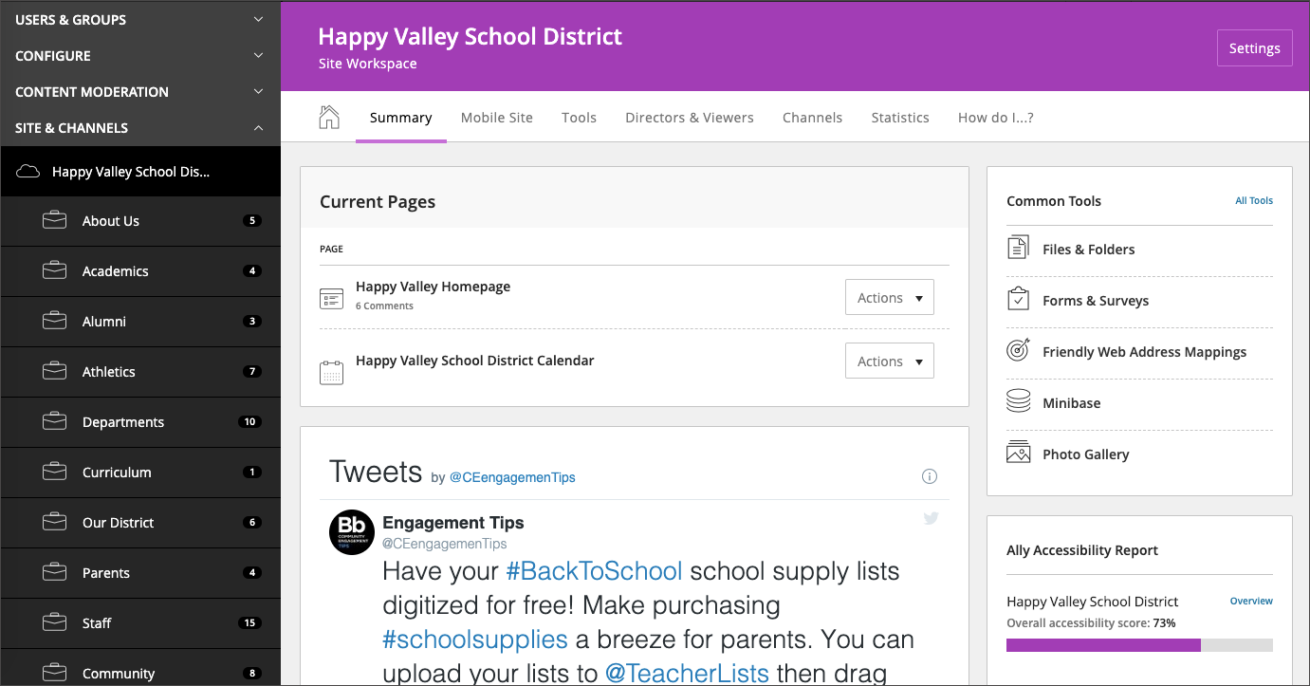

Design Ready Templates
Our Design Ready Templates require updates when defects are found, accessibility guidelines change, new WCM features change, etc. We've made it easier for you to keep track of updates with our subscription service. When an update has been applied to a Design Ready Template that you have subscribed to, you receive an email with the release information. You can review the release information before clicking the "Update" button for the template.

Subscribe to template updates

Resolved Issues
We have resolved the following issues in this release. We’ve listed the issues as they were originally entered and in the order that they were reported.
Functional Area | Subject
Google Calendar | Notify the Google Calendar owner when there’s an error due to a Google process
 | Notify the user that a Google connection exists when a page with a calendar is deleted from the recycle bin
 | Notify the user when a page is deleted with an active Google connection

Technical Requirements
Here are the Web Community Manger End-User Technical Requirements.
The Blackboard Privacy Policy updated to reflect the Blackboard brand.

Refresh Your Cache
It's always a good practice to clear your browser cache on a regular basis. Refresh your Cache shows you how to clear your cache in any browser.

Resources and Materials
As always, you can find resources and materials related to this release as well as to the many features and functions on the Blackboard Help website. Core Resources and Hot Help Topics, Apps Showroom, Training and Creative—we’ve got the information you need to succeed with your Web Community Manager website.

