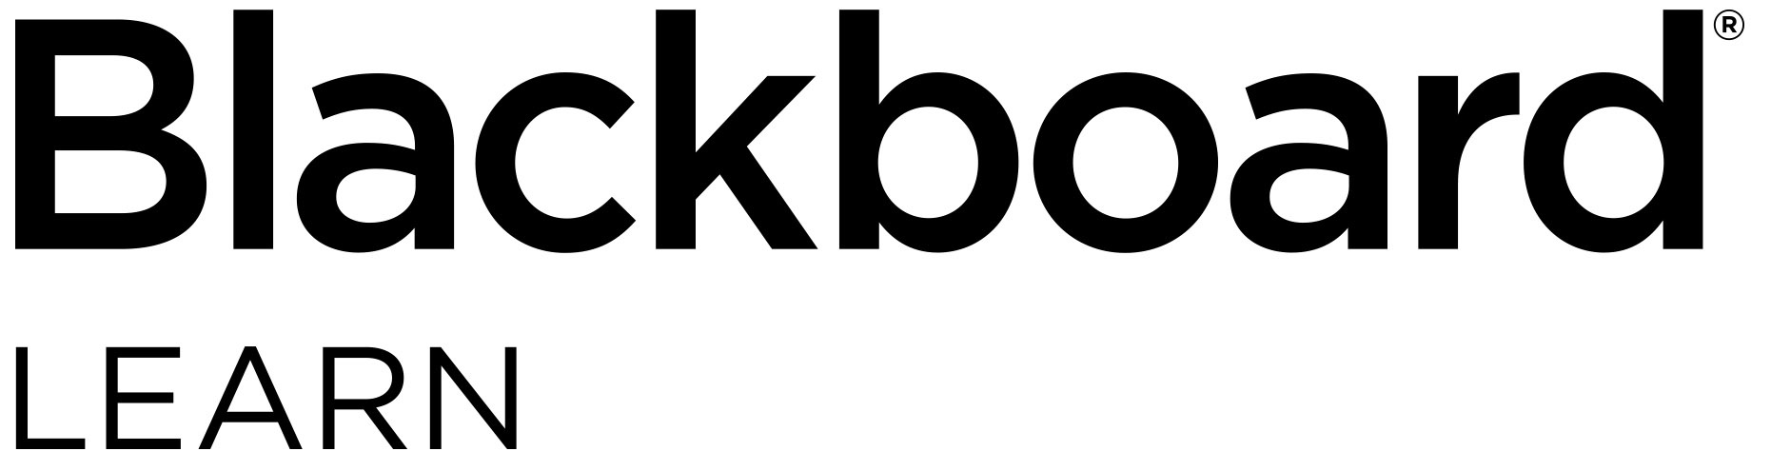

Educators: Check out what’s new for

Blackboard Learn

Overview of th

e newest features and enhancements

**The following new features and enhancements were made available within the past year.**

Efficiency & Engagement

* Calendar items and due date notifications for additional content types – You and your students will now have a more comprehensive view of all class requirements and activities as the Calendar and To Do modules now include the due dates from additional content types: manual columns, SCORM, and third-party solutions.
* New Facilitator course role and more granular permissions – For institutions that centrally manage course development and settings, these more granular course role permissions enable roles to teach, engage, and grade, but not modify materials or settings. There is also a new default course role called Facilitator. As with other default course roles, the specific permissions can be edited.
* Blackboard CollaborateTM attendance integration – When hosting Collaborate sessions, taking attendance is now automated, eliminating the need for manual tracking. Collaborate session attendance is recorded within the Attendance page of the Learn course, is counted in the average attendance calculation, and can be factored into students’ grades.
* Content Collection updates – To improve the performance and usability of the Content Collection, files uploaded as part of a SCORM package are now shown in the Content Collection folder. When versioned files are imported/restored, the version number is indicated in the file name.
* Cloud storage integration – Save time by uploading documents directly from your preferred cloud storage solution when authoring content or creating assignments. Your students can also upload assignments directly from their chosen solution.
* Enhanced accessibility – To make it easier for those who use assistive technologies to navigate the structure of pages, skip links now work more consistently across Learn tool areas.
* Nynorsk language support – Support for Nynorsk (written Norwegian) has been added.

Assessment & Grading

* New SafeAssign Originality Report – The SafeAssign Originality Report has been updated and reformatted for improved usability, responsiveness, and accessibility. It employs Blackboard’s Ultra design philosophy and includes new information about the overall risk of a submission having been copied.
* Improved Grades Journey support for merged courses – Institutions using merged courses can now more readily use all the capabilities of Grades Journey.
* Download annotated PDFs – A highly requested feature, you can now download your annotated files for permanent record using New Box View. DOC, DOCX, or PDF files with annotations will download as an annotated PDF. Your students can download their annotated file after the submission has been graded.
* Grading in the Blackboard Instructor app – To make grading on the go easier, you can now grade assignments using the Instructor app. You can review assignment submissions and attachments, provide comments and inline annotations, grade with rubrics, and publish grades to students.
* Granting grade reconcilitation added to delegated grading– You now have the authority to grant grade reconciliation permission to any or all other graders within your course. When grading is delegated, the “Can reconcile grades” option appears. Granting grade reconciliation is now as simple as checking a box.

**Standards & Interoperability**

To ensure you’re able to integrate your portfolio of solutions with Blackboard Learn in a deep, rich, and consistent way, we continue to invest significantly in building more REST APIs and supporting IMS standards including Learning Tools Interoperability (LTI) and Questions and Test Interoperability (QTI). This work ensures a deep integration between Blackboard Learn and other technoloies—all to drive towards the most powerful user experience for you and your students.

* LTI Advantage certified and in production Blackboard Learn is the first major LMS to make LTI Advantage available. [LTI Advantage](https://www.imsglobal.org/lti-advantage-overview) is the latest in interoperability standards for integrating tools into a learning environment. The capabilities of LTI Advantage allow for deeper, richer, and more consistent and secure integrations than with previous LTI versions.
* Support for IMS Global’s Questions and Test Interoperability (QTI) specification To simplify your online management of assessment, you are now able to add and export Learn question pools as QTI packages.

**The latest releases for the Original experience of Blackboard Learn include new features and enhancements that:**

Save time by improving the efficiency and ease of use of completing your daily tasks

Ensure your courses are engaging, accessible to all, and mobile friendly

Simplify and enhance the assessment and grading capabilities

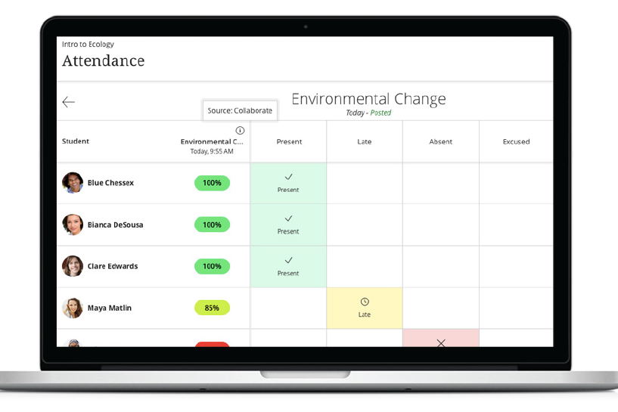

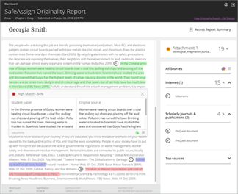

For more details on these new features and enhancements, visit [**help.blackboard.com**](https://help.blackboard.com/Learn/Instructor). Plus, share your product suggestions and vote on ideas for our upcoming releases in the [**Blackboard Idea Exchange**](https://community.blackboard.com/community/ideasmain).

Note: The features and enhancements highlighted above were made available in the Learn Q2 2019 and Q4 2018 releases. In addition to the above, each release addresses the top client-reported issues to ensure the best user experience.



1111 19th St NW | Washington, DC 20036 | 1.800.424.9299