

Check out what’s new for

Blackboard Learn

Overview of the newest features and enhancements

**The following new features and enhancements were made available over the past year.**

Efficiency & Ease of Use

* Cloud storage integration – Save time by uploading documents directly from your preferred cloud storage solution when creating content or assignments. Your students can also upload assignments directly from their chosen solution.

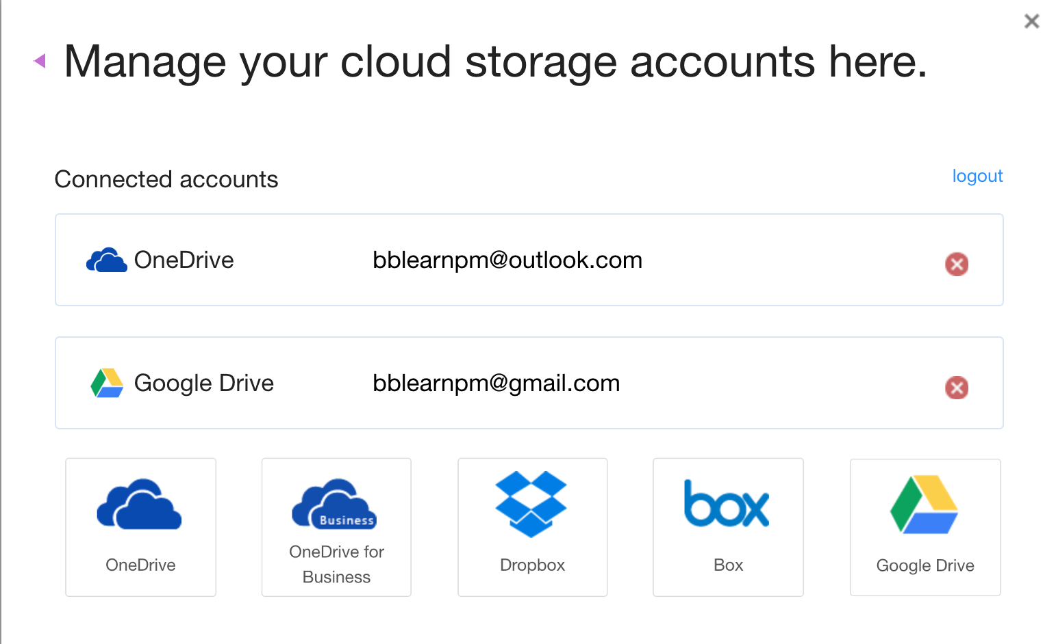

* Course availability status – You can now easily see the availability of your course to students and quickly change the availability from the main course view.
* Discussion board “replies to me” – Keeping up with large discussion board forums is easier for you and your students with this new count and filter that enables you to quickly identify unread replies to your own posts.

User Experience (Mobility & Accessibility)

* Grading in Blackboard Instructor App – Using the Blackboard Instructor mobile app, you can now review assignment submissions and attachments, provide comments and inline annotations, grade with rubrics, and publish grades to students – making this the easiest way to grade on the go.
* Improved mobile experience – To provide an enjoyable mobile experience, Learn is continuously optimized for use on mobile devices. Most recently, system and course level navigation, Blogs, Journals, Tests and the Learning Modules tool were optimized for mobile devices.
* Course color configuration – You can now configure your course colors in the course control panel. The course menu will present in these colors in both the desktop and mobile web browser.
* Collaborate sessions for groups – Enable real-time, face-to-face web conferencing among your students by adding Collaborate sessions to Group pages.
* Ally integration – Improve the accessibility of your content with this new service for Learn. Ally provides an accessibility score for your content, suggests ways to improve the accessibility of materials, and automatically generates alternative versions of your files, such as accessible HTML, digital braille, and audio format files.

Assessment & Grading

* Attendance tracking – For each class meeting, you can mark whether a student is present, late, absent, or excused. The attendance record for each student appears in a single column next to other grades in the gradebook. On the Attendance page, profile pictures appear so you can easily identify students.



* Grade center enhancements – You will now be able to view full titles of Grade Center columns making it easier to distinguish between similarly-titled items. You can also view as many columns as the size of your browser window will allow, and enter Grade Center full-screen mode to make the most of your desktop experience.
* Additional attempts in anonymous grading You can grant additional Assignment attempts to students as needed, while still maintaining the full anonymity of the process.
* Delete multiple gradebook columns

You can now delete multiple gradebook columns at once making managing the gradebook even easier.

* Record feedback for students – Make your feedback more personalized and engaging by creating an audio or video recording. Simply click on the microphone icon in the Content Editor. Students will access it by clicking the recording icon which immediately launches the streamed content without the need of a browser plug-in.



* Clear multiple-choice selection – Students are now able to clear a selection from multiple-choice questions (leaving it blank) when negative points are associated with incorrect answer choices.
* Improved grading with rubrics – You can now save feedback and the content will remain saved when changing the rubric view from in-line to full screen.
* Grade display standardization – To provide greater consistency, all gradebook columns and My Grades now support up to five decimal points, are not rounded, and are consistent for all display types.

**The latest releases for the Original experience of Blackboard Learn include many new features and enhancements that:**

Save time by improving the efficiency and ease of use of completing your daily tasks

Ensure your courses are accessible to all and mobile friendly

Simplify and enhance the assessment and grading capabilities





Note: The new features and enhancements highlighted above were made available in the Q2 2018, Q4 2017 and Q2 2017 releases of Learn. In addition to the highlights above, each release addresses the top client-reported issues to ensure the best user experience.

For more details on these new features and enhancements, visit [help.blackboard.com](https://help.blackboard.com/Learn/Instructor). Plus, share your product suggestions and vote on ideas for our upcoming releases in the [Blackboard Idea Exchange](https://community.blackboard.com/community/ideasmain).

1111 19th St NW | Washington, DC 20036 | 1.800.424.9299