What’s New in Blackboard Learn: Feature Guide for End Users
Table of Contents
Introduction 2
Purpose of this Document [Note: Delete before providing to educators and learners] 2
Introduction 2
Learn 9.1 Q2 2018 release enhancements 2
Additional attempts in Anonymous Grading 2
Attendance tracking 3
Clear multiple-choice selection 4
Cloud storage integration [Note: This service will become available via a Cumulative Update to the Q2 2018 release. Check the release notes for availability of this feature.] 4
Course color configuration [Note: Delete if you are not using the Learn 2016 Theme.] 4
Create recording for feedback [Note: Availability of the service will vary by region. Check the release notes for availability of this feature.] 4
Grade Center enhancements [Note: Delete if you are not using the Learn 2016 Theme.] 5
Grading in Blackboard Instructor App 5
Learning Tools Interoperability (LTI) names and roles provisioning service 6
LTI Course tool updates 7
Learn 9.1 Q4 2017 release enhancements 7
Accessibility enhancement – ARIA landmarks 7
Blackboard app download module 7
Chemistry notation support 7
Collaborate with the Ultra experience sessions for groups [Note: Delete if you do not license Collaborate] 8
Course availability status 8
Delete multiple gradebook columns 9
Discussion board “replies to me” 10
Enhanced mobile experience for Blogs and Journals 10
Enhanced mobile experience for navigating Learn 10
Grade display standardization 10
Improved grading with rubrics 11
Learning Tools Interoperability (LTI) deep linking [Note: This section requires editing.] 11
Learn 9.1 Q2 2017 release enhancements 11
Additional drag-and-drop locations 11
Blackboard Ally, a solution for better accessibility Note: Delete if you do not license Ally. 11
Continued mobile optimization Note: Delete if you are not using the Learn 2016 Theme. 12
Submission receipt enhancements 12
Additional resources 12
Blackboard Help Site 12
Blackboard Community Site 13

Introduction

Purpose of this Document [Note: Delete before providing to educators and learners]
The purpose of this document is to provide system administrators or instructional designers with an end-user feature guide that can be easily customized for sharing with your educators and learners. The features covered are part of our latest Blackboard Learn releases (Q2 2018, Q4 2017 and Q2 2017).
We invite you to customize and share this document as you see fit, based on the version of Blackboard Learn you are upgrading from. To make customization easy, we have separated the enhancements by release, so you can remove the releases that do not apply to your institution’s upgrade.

Introduction
We have recently updated our Blackboard Learn environment to a new version, which includes many new features and enhancements that will:
- Simplify and enhance many capabilities you currently use today
- Save you time and make it easier to complete your daily tasks
- Provide a much-improved mobile experience
- Improve the accessibility of the learning environment
This document will provide you, educators and students, with an overview of these new features and enhancements that are now available in Blackboard Learn.
____________________________________________________

Learn 9.1 Q2 2018 release enhancements

Additional attempts in Anonymous Grading
Feature enhancement for instructors
To better support anonymized assessment practice, you can now grant additional assignment attempts to students as needed while still maintaining the full anonymity of the process.
The “Allow Additional Attempt’ button only appears if a student has already submitted the maximum number of attempts allowed for that assignment. You can continue to offer opportunities to resubmit attempts each time a student reaches the maximum number. You don't have to grade previous attempts to allow a student to submit again.
When an assignment is in an anonymous state, you can still grant a student an additional attempt. You can view student names, but not their submissions or how many attempts are left. Your request is ignored if attempts remain.
Alternatively, select “Ignore Attempt” to ignore the attempt's score in grade calculations and not count it against the maximum number of attempts.
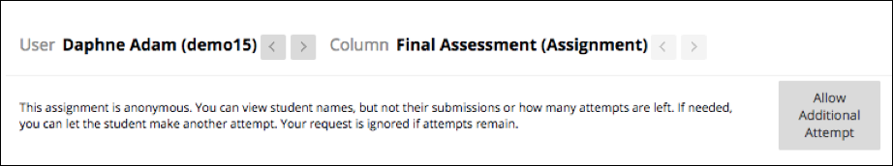

Attendance tracking
Feature enhancement for instructors
You can now track attendance in your Learn course. For each class meeting, you can mark whether a student is present, late, absent, or excused. The attendance records appear in a single column next to the gradebook. The Attendance column provides the overall attendance score in the gradebook, where it can be included in the student’s overall grade.

Note: Attendance is not supported on Internet Explorer 11.

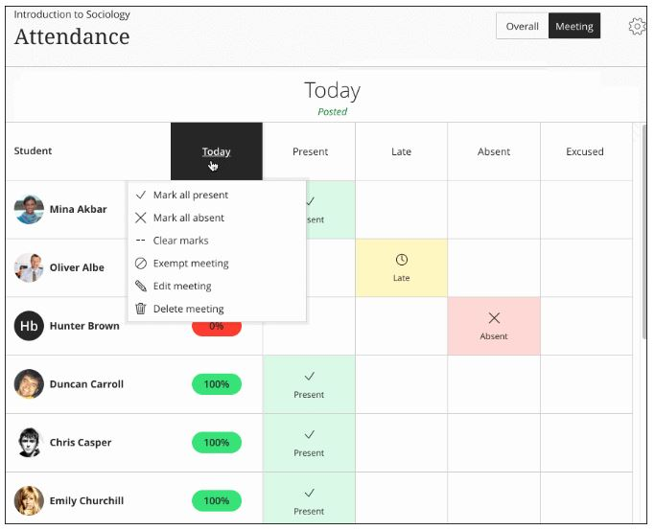

Clear multiple-choice selection
Feature enhancement for all users
Students can clear a selection from multiple-choice questions. This allows students to clear their selection – essentially leaving the question blank – after having made an initial selection in order to avoid a penalty when an instructor has associated negative points with an incorrect answer.

Cloud storage integration [Note: This service will become available via a Cumulative Update to the Q2 2018 release. Check the release notes for availability of this feature.]
Feature enhancement for all users
An instructor can now upload files from a favorite cloud storage solution when authoring Content Items or creating Assignments. Students can upload assignments from their favorite cloud storage solutions. Cloud storage that is supported includes OneDrive, OneDrive for Business, Google Drive including G suite accounts, Dropbox, and Box.
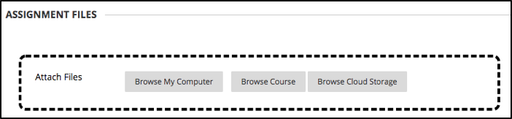

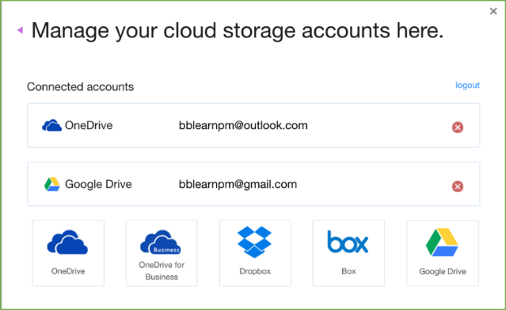

Course color configuration [Note: Delete if you are not using the Learn 2016 Theme.]
Feature enhancement for instructors
Colors for individual courses are now configurable in the course Control Panel. The Course Menu area appears in these selected colors in both desktop and mobile experiences. Extended menu areas such as the Control Panel for instructors and My Groups menu for students remain in the gray and white color scheme.

Create recording for feedback [Note: Availability of the service will vary by region. Check the release notes for availability of this feature.]
Feature enhancement for all users
Instructors can create personalized feedback recordings for students pertaining to individual assessment attempts or manual gradebook items. Each recording can be up to 5 minutes long and can be video and audio or just audio. This option appears in the third row of the Content Editor as a microphone icon.

Students will see icons representing recordings that they can select to start streaming playback of the video on their computer or mobile device.

Feedback can be provided within:
- Assignment  - Test  - Graded Discussion  - Graded Wiki | • Graded Blog  • Graded Journal  • Feedback in a manual grade column
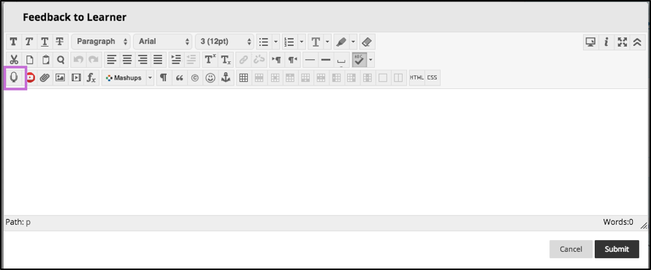
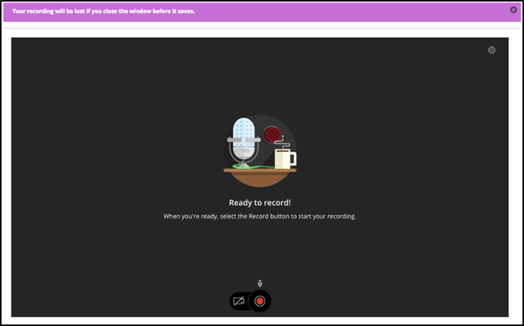

Grade Center enhancements [Note: Delete if you are not using the Learn 2016 Theme.]
Feature enhancement for instructors
The following improvements have been made to the grade center:
- View full titles of Grade Center columns, making it easier to distinguish between similarly-titled items,
- View as many columns as the size of your window will allow, and
- Go into Grade Center full-screen mode to make the most of your desktop experience.

Grading in Blackboard Instructor App
Feature enhancement for instructors
The Blackboard Instructor app helps you easily identify courses where you need to grade student submissions. Instructors and graders can review, annotate, and grade submissions and quickly publish the grades back to students on iOS and Android devices. You can access grading in two ways:
- Main menu. Tap “Grades” for a global view of items to grade or post for all courses
- Course overview. See items that need your attention now or tap “Grades” to see all assessments for a single course
Grading is supported on both phones and tablets. All screen sizes have the same functions, but the interface is slightly different between phones and tablets.
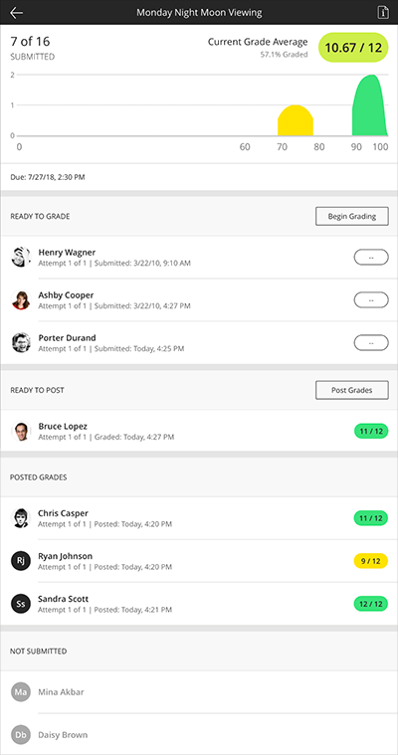
Mobile optimization enhancements [Note: Delete if you are not using the Learn 2016 Theme.]
Feature enhancement for all users
Tests and the learning modules tool are now optimized for mobile devices. In the Learning Modules tool, the table of contents will always be pinned to the bottom of the page and can be expanded or collapsed. In Tests, additional question types have been optimized for use on mobile devices.

Learning Tools Interoperability (LTI) names and roles provisioning service
Feature enhancement for instructors
Formerly known as LTI Membership Service, this LTI service allows tools to request the course roster to create better end user experiences. Integrated tools can retrieve course roster information to support assessment activities or provide better information about the class within the tool.
For example, an assessment tool might request the roster to present you with grading progress information by showing students who have and have not submitted; or an interactive tool might allow creating groups of students from roster information.

LTI Course tool updates
Feature enhancement for instructors
The Assessment option under Course Tool placement has been removed. There is now a setting for Student Tool and Content Type. Placements previously set to use the Assessment placement type will continue to display in the same way. If the placement is edited, the course tool type will be changed.
Password reset enhancement
Feature enhancement for all users
When using Learn's password reset function, the password reset URL sent through email now expires in 15 minutes for greater security.
____________________________________________________

Learn 9.1 Q4 2017 release enhancements

Accessibility enhancement – ARIA landmarks
Feature enhancement for all users
ARIA landmarks have been incorporated in the course menu and the content area to better define the page structure and assist users with screen readers in navigating page elements. Additionally, the first-time user overlay has been removed to improve accessibility for all.

Blackboard app download module
Feature enhancement for students
A new module called “Download Blackboard’s Student App Today” helps students discover and quickly download the app. The module includes links to the Apple, Android, and Windows app download locations.
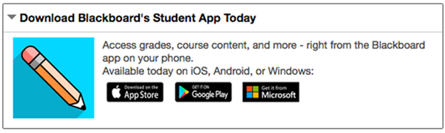

Chemistry notation support
Feature enhancement for all users
Chemistry tools, like an embedded periodic table of elements, are now included in the math editor found in the Content Editor.
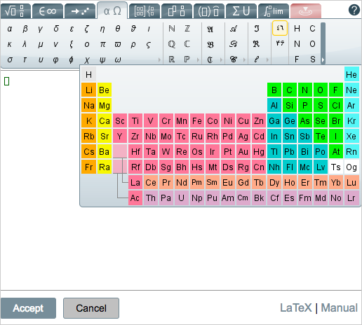

Collaborate with the Ultra experience sessions for groups [Note: Delete if you do not license Collaborate]
Feature enhancement for all users
Improve collaboration amongst student groups doing group work with the addition of Collaborate sessions to Group pages. Collaborate sessions offer real-time, face-to-face web conferencing, content sharing, and whiteboard functionality.

Course availability status
Feature enhancement for instructors
From the main course view, you can now easily see an open or closed padlock icon representing the availability of the course to students and quickly change the availability with one click, saving both time and effort. This new feature can be seen below, next to tools such as Student Preview and the Edit Mode toggle.
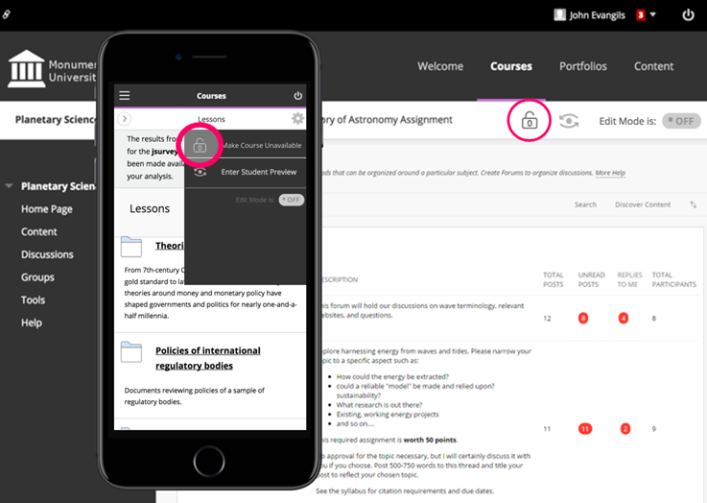

Delete multiple gradebook columns
Feature enhancement for instructors
You can now delete multiple gradebook columns at once making managing the gradebook even easier. When deleted, manual and calculated columns are removed completely; columns associated with gradable items are cleared of attempt and grade data but remain in the Grade Center.
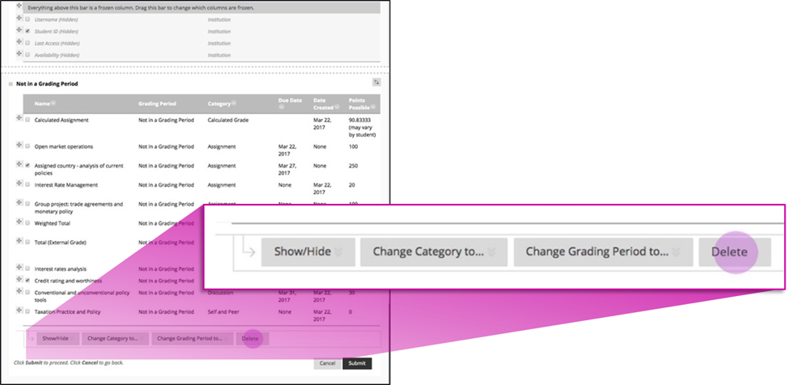

Discussion board “replies to me”
Feature enhancement for all users
Keeping up with large discussion board forums is made easier with the addition of a “Replies to me” count and filter so unread replies to your own posts can be easily identified and read.
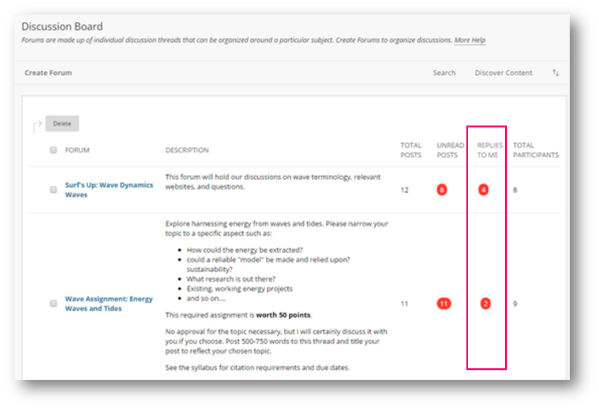

Enhanced mobile experience for Blogs and Journals
Feature enhancement for all users
You will now have a much-improved experience using Blogs and Journals on your mobile device. For example, options for filtering posts or navigating groups or users will appear below currently viewed posts.

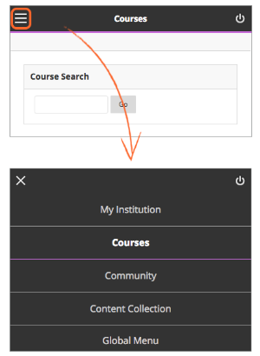
Enhanced mobile experience for navigating Learn
Feature enhancement for all users
It is now much easier to navigate the system and course menus on mobile devices. When you access Blackboard Learn through mobile devices, you’ll notice that the navigation has been moved to a hamburger menu that remains there when you move from screen to screen. Tabs and subtabs now appear in your navigation choices. My Blackboard has also been incorporated into the system menu for easier access. Within a course, the menu opens and closes more easily, improving the overall experience.

Grade display standardization
Feature enhancement for instructors
To provide greater consistency and standardization, all gradebook columns (online and downloads) and My Grades now support up to five decimal points, are not rounded, and are consistent for all display types (score, percentage, letter grade).

Improved grading with rubrics
Feature enhancement for instructors
When grading with rubrics, you can now save feedback and the content will remain saved when changing the rubric's view from in-line to full screen.

Learning Tools Interoperability (LTI) deep linking [Note: This section requires editing.]
Feature enhancement for all users
You will now have a more seamless experience when linking or integrating with tools like [Note: enter the names of some tool providers your institution / your instructors use who support the LTI deep linking specification]. You can create links to specific resources without knowing and specifying resource IDs. Instead, you can launch into the tool provider’s user experience, select resources to add to your course, and the individual links are created in the correct place in the course. Students clicking the links will be taken directly to the specific resource rather than to a generic tool page.
____________________________________________________

Learn 9.1 Q2 2017 release enhancements

Additional drag-and-drop locations
Feature enhancement for all users
The drag-and-drop feature is now added to the Content Editor, Blog, Journal, and Portfolios. If the browser allows, you can drag a folder of files and the files will upload individually.

Blackboard Ally, a solution for better accessibility Note: Delete if you do not license Ally.
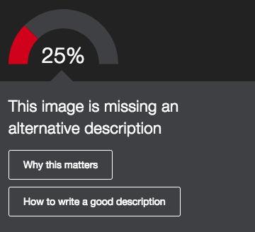
Feature enhancement for all users
Ally is a new service for improving content accessibility that has been integrated into Learn. Ally improves accessibility within Learn in the following ways:
- Instructors can view an accessibility score and learn ways to improve the accessibility of materials.
- Students can download automatically-generated alternative versions of uploaded files, such as accessible HTML, digital braille, and audio format files.

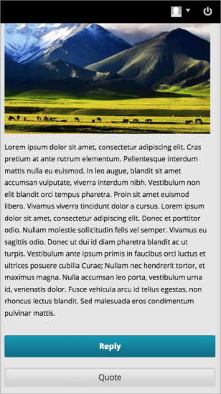
Continued mobile optimization Note: Delete if you are not using the Learn 2016 Theme.
Feature enhancement for all users
The discussion board is now responsive for mobile devices if the post contents are responsive. That means you will be able to easily read, respond, and use other discussion features such as post rating when using your mobile device – and the experience will be a great one!
Additionally, pages with tables, the course menu, and within My Blackboard are better optimized for mobile devices. Contextual menus can also be accessed on both tablet and mobile devices.

Submission receipt enhancements
Feature enhancement for all users
Students can receive a notification email for each assignment attempt with information about the submission, including attached files. Students can also access receipts at any time on the My Grades page in the submissions filter area.

____________________________________________________

Additional resources

Blackboard Help Site
- Blackboard's Help Site is your one-stop-shop to find product documentation for Blackboard products, including Blackboard Learn. This site allows anyone to view help documentation (students, instructors, or administrators), while adaptive search and tagging help you find what you’re looking for. Check it out here:
  - https://en-us.help.blackboard.com/
- Release notes – The Help Site is also your source for the Release Notes documenting each release. For Learn 9.1, you can find the Release Notes here:
  - https://help.blackboard.com/Learn/Administrator/Hosting/Release_Notes
- Other Communication and Adoption Toolkits - To assist you in promoting the benefits of technology to your instructors, we have developed product/release-specific Communication and Adoption Toolkit webpages. These assets are for you to use and customize for your institution to aid with promoting the use of technology.
  - https://help.blackboard.com/Learn/Administrator/Hosting/Release_Notes/Adoption_Tools_and_Best_Practices#toolkits

Blackboard Community Site
- The Blackboard community is the largest organized network of e-learning users. Join the conversation with other educators here:
  - https://community.blackboard.com/community/questions/educator
- Make sure that your ideas about our products and the future of teaching and learning are heard loud and clear by peers and Blackboard staff here:
  - https://community.blackboard.com/community/ideasmain
- Check out the Blackboard Innovative Teaching Series (BITS) hosted by Blackboard’s community of users and product experts to hear strategies and best practices for increasing efficiency and improving learning outcomes. You can register for live webinars or watch recordings of past webinars here:
  - https://community.blackboard.com/groups/higheredbits

