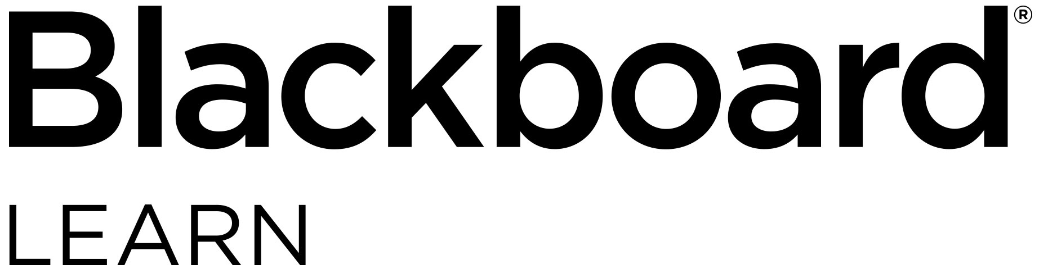

Students: Check out what’s new for

Blackboard Learn

Overview of the newest features and enhancements

**The new 2018 features and enhancements in Blackboard Learn will:**

Save you time by making it easier to complete your daily tasks

Ensure your courses are engaging and mobile friendly

Improve accessibility of navigating Learn

**The following new features and enhancements are now available in Learn to save you time and to provide you with a more enjoyable learning experience.**

* Cloud storage integration – Save time by uploading assignments directly from your preferred cloud storage solution.

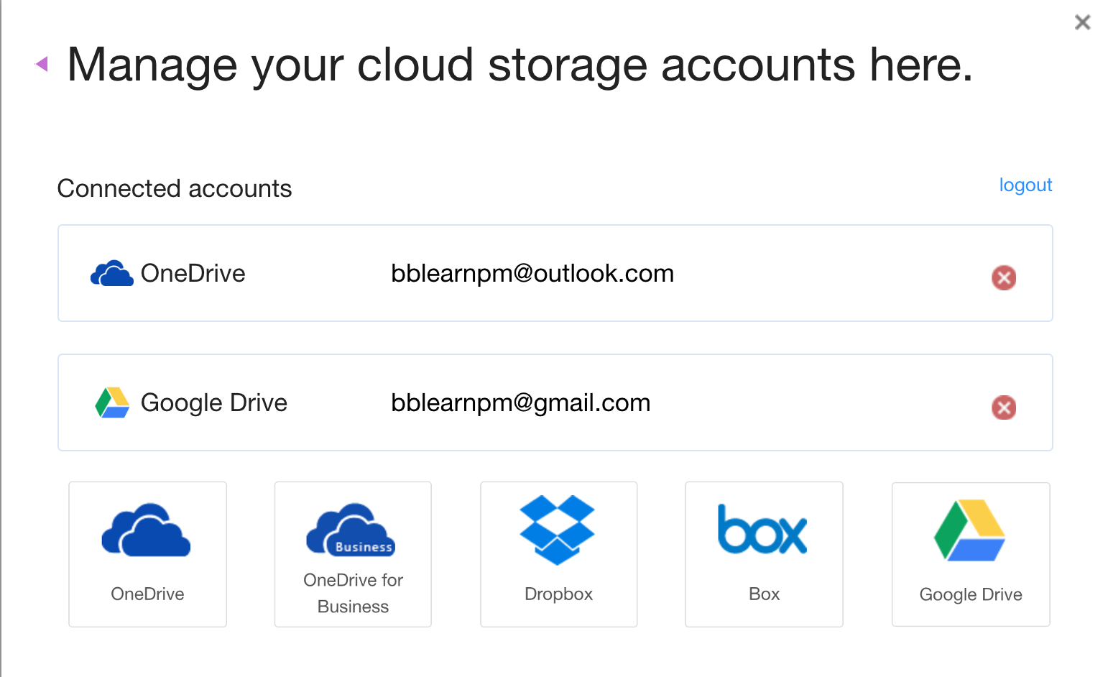

* **Improved mobile experience** – To provide a more enjoyable experience when accessing Blackboard Learn in a mobile web browser, e.g. Safari, you will notice that additional areas of Learn have been optimized for use on mobile devices.
* Enhanced accessibility - To make it easier for students who use assistive technologies to navigate the structure of pages, skip links now work more consistently across Learn tool areas.
* Get personalized feedback – If your instructors elect to, they can now create an audio or video recording offering you personalized feedback. You will access it by clicking the recording icon which immediately launches the streamed content.
* Download instructor-annotated assignment submissions – Once your submission has been annotated with feedback and graded, it can now be downloaded for your records. DOC, DOCX, or PDF files with annotations will download as an annotated PDF.
* Clear multiple-choice selection – When taking a test that associates negative points to incorrect answer choices, you are now able to clear a selection from a multiple-choice question; thereby leaving it blank.

1111 19th St NW | Washington, DC 20036 | 1.800.424.9299



For more details on these new features and enhancements, visit [help.blackboard.com](https://help.blackboard.com/Learn/Student).