

Educators: Check out what’s new for

Blackboard Learn

Overview of the newest features and enhancements

**The latest releases for the Original experience of Blackboard Learn include new features and enhancements that:**

Save time by improving the efficiency and ease of use of completing your daily tasks

Ensure your courses are engaging, accessible to all and mobile friendly

Simplify and enhance the assessment and grading capabilities



**The following new features and enhancements were made available over the past year.**

Efficiency & Engagement

* Cloud storage integration – Save time by uploading documents directly from your preferred cloud storage solution when authoring content or creating assignments. Your students can also upload assignments directly from their chosen solution.

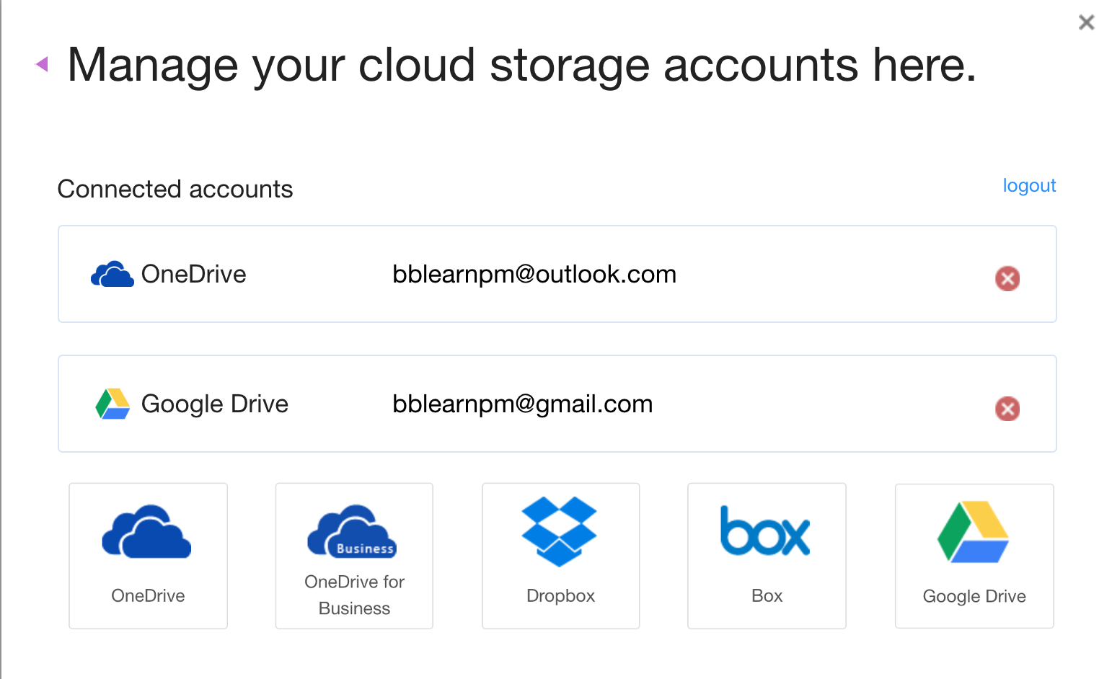

* Record feedback for students – Make your feedback more personalized and engaging by clicking on the microphone icon in the Content Editor to create an audio or video recording. Students will access it by clicking the recording icon which immediately launches the streamed content without the need of a browser plug-in.
* Improved mobile experience – To provide an enjoyable mobile experience, additional areas of Learn have been optimized for use on mobile devices. Most recently, Tests and the Learning Modules tool were optimized. In the Learning Modules tool, the table of contents will always be pinned to the bottom of the page, and can be expanded or collapsed. In Tests, additional question types have been optimized for use on mobile devices.
* Course color configuration – You can now configure your course colors in the course control panel. The course menu will present in these colors in both the desktop and mobile web browser.
* Enhanced accessibility - To make it easier for those who use assistive technologies to navigate the structure of pages, skip links now work more consistently across Learn tool areas.
* Nynorsk language support – Support for Nynorsk (written Norwegian) has been added.

Assessment & Grading

* Attendance tracking – For each class meeting, you can mark whether a student is present, late, absent, or excused. The attendance record for each student appears in a single column next to other grades in the gradebook. On the Attendance page, profile pictures appear so you can easily identify students.



* Grading in the Blackboard Instructor app – To make grading on the go easier, you can now grade assignments using the Instructor app. You can review assignment submissions and attachments, provide comments and inline annotations, grade with rubrics, and publish grades to students.
* Download annotated PDFs – A highly requested feature, you can now download your annotated files for permanent record using New Box View. DOC, DOCX, or PDF files with annotations will download as an annotated PDF. Your students can download the annotated file after their submission has been graded.
* Granting grade reconcilitation added to delegated grading– You now have the authority to grant grade reconciliation permission to any or all other graders within your course. When grading is delegated, the “Can reconcile grades” option appears. Granting grade reconciliation is now as simple as checking the box.
* Additional attempts in anonymous grading You can grant additional Assignment attempts to students as needed, while still maintaining the full anonymity of the process.
* Grade center enhancements – You will now be able to view full titles of Grade Center columns making it easier to distinguish between similarly-titled items. You can also view as many columns as the size of your browser window will allow, and enter Grade Center full-screen mode to make the most of your desktop experience.
* Improved grading with rubrics – You can now save feedback and the content will remain saved when changing the rubric view from in-line to full screen.
* Clear multiple-choice selection – Students are now able to clear a selection from multiple-choice questions (leaving it blank) when negative points are associated with incorrect answer choices.



Note: The new features and enhancements highlighted above were made available in the Q4 2018 and Q2 2018 releases of Learn. In addition to the highlights above, each release addresses the top client-reported issues to ensure the best user experience.

For more details on these new features and enhancements, visit [help.blackboard.com](https://help.blackboard.com/Learn/Instructor). Plus, share your product suggestions and vote on ideas for our upcoming releases in the [Blackboard Idea Exchange](https://community.blackboard.com/community/ideasmain).

1111 19th St NW | Washington, DC 20036 | 1.800.424.9299