

**CHECK OUT WHAT’S NEW FOR BLACKBOARD LEARN**

Overview of the newest features and enhancements

**Blackboard.com**

The latest releases for the Original experience of Blackboard Learn include many new features and enhancements that:

* Save you time by improving the efficiency and   
  ease of use of completing your daily tasks
* Provide a much improved mobile experience
* Improve the accessibility of both your content   
  and Learn functionality
* Simplify and enhance the assessment and   
  grading capabilities

The following new features and enhancements were made available over the past year for Learn.

Efficiency & Ease of Use

* Course availability status – You can now easily see the availability of the course to students and quickly change the availability from the main course view.

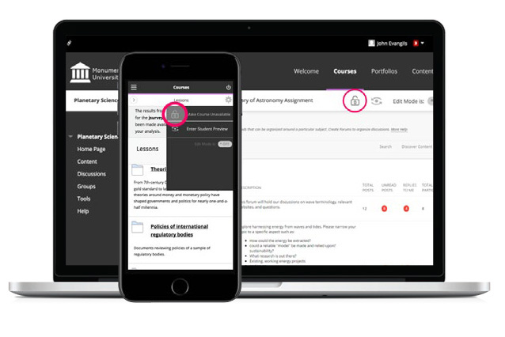

* Discussion board “replies to me” Keeping up with large discussion board forums is easier with a new count and filter to quickly identify unread replies to your own posts.
* Learning Tools Interoperability (LTI) deep linking – You will have a more seamless experience when linking or integrating with tool providers who also support this standard. You can now create links to specific resources without knowing and specifying resource IDs. Instead, you simply launch into the tool provider’s user experience, select resources to add to your course, and the individual links are created in the correct place in your course. Students clicking the links will be taken directly to the specific resource rather than to a generic tool page for the tool provider.
* Drag and drop files – You can now quickly and easily drag and drop files from your desktop to the “hot spot” in the Attach Files area to upload them. Students can also drag and drop files to upload when they submit assignments.
* Dropbox integration – Using this new cloud service integration, you and your students can link to your Dropbox content directly from Learn using the mashup menu found in most content creation workflows.
* Course activity report enhancement – To help simplify the management of large enrollment courses, this report can now be filtered to break down the calculations of student activity by course groups.

User Experience (Mobility & Accessibility)

* Improved mobile experience – Each release further expands the areas of Learn optimized for use on mobile devices (if your institution is using the Learn 2016 theme), providing a much improved and more enjoyable mobile experience. Most recently, system and course level navigation, blogs, and journals were optimized for mobile devices.
* Chemistry notation support – Chemistry tools, like an embedded periodic table of elements, are now included in the math editor found in the Content Editor.
* Collaborate sessions for groups – Enable real-time, face-to-face web conferencing among your students by adding Collaborate sessions to Group pages. *Blackboard Collaborate license is required.*
* Blackboard Ally integration – Greatly improve the accessibility of your content with this new service for Learn. Ally provides an accessibility score for your content and suggests ways to improve the accessibility of materials. Ally also automatically generates alternative versions of your files, such as accessible HTML, digital braille, and audio format files. *Blackboard Ally license is required.*
* Additional accessibility enhancements To improve accessibility, ARIA landmarks have been incorporated in the course menu and the content area to better define the page structure and assist users with screen readers in navigating page elements.

Assessment & Grading

* Delete multiple gradebook columns

The #1 requested feature voted by clients on the Community Site, you can now delete multiple gradebook columns at once making managing the gradebook even easier.

* Improved grading with rubrics - You can now save feedback and the content will remain saved when changing the rubric's view from in-line to full screen.
* Grade display standardization – To provide greater consistency, all gradebook columns (online and downloads) and My Grades now support up to five decimal points, are not rounded, and are consistent for all display types (score, percentage, letter grade).
* Submission receipts – Keep track of all student submissions, regardless of whether the attempt or assignment is deleted or the submission history is changed. A submission receipt gives students assurance about their work and can provide evidence for academic disputes.
* Missing coursework reminders – You can now send email reminders directly from Grade Center columns to students and members of groups who have missing coursework.
* Grade Center improvements – When multiple-attempt assessments are set to calculate using the first or last attempt, a new filter is available both in the Needs Grading workflow and the Grade Center to show or hide other non-counted attempts.



For more details on these new features and enhancements, visit [help.blackboard.com](https://help.blackboard.com/Learn/Instructor). Plus, share your product suggestions and vote on ideas for our upcoming releases in the [Blackboard Idea Exchange](https://community.blackboard.com/community/ideasmain).

**Blackboard.com** | 1111 19th St NW | Washington, DC 20036 | 1.800.424.9299

Note: The new features and enhancements highlighted above were made available in the Q4 2017, Q2 2017 and Q4 2016 releases of Learn. In addition, each release addressed the top client-reported issues to ensure the best user experience.

