What’s New in Blackboard Learn: Feature Guide for End Users
Table of Contents
Introduction 2
Purpose of this Document [Note: Delete before providing to educators and learners] 2
Introduction 2
Blackboard Learn Q4 2017 Enhancements 3
Accessibility enhancement – ARIA landmarks 3
Blackboard app download module 3
Chemistry notation support 3
Collaborate with the Ultra experience sessions for groups [Note: Delete if you do not license Collaborate] 4
Course availability status 4
Delete multiple gradebook columns 4
Discussion board “replies to me” 5
Enhanced mobile experience for Blogs and Journals 5
Enhanced mobile experience for navigating Learn 6
Grade display standardization 6
Improved grading with rubrics 6
Learning Tools Interoperability (LTI) deep linking [Note: This section requires editing.] 6
Blackboard Learn Q2 2017 Enhancements 6
Additional drag-and-drop locations 6
Blackboard Ally, a solution for better accessibility Note: Delete if you do not license Ally. 7
Continued mobile optimization Note: Delete if you do not have the Learn 2016 Theme enabled. 7
Submission receipt enhancements 7
Blackboard Learn Q4 2016 Enhancements 8
A new look & feel with an improved mobile experience Note: Delete if you do not have the Learn 2016 Theme enabled. 8
Course activity reports 8
Drag and drop files 8
Dropbox Education Integration 9
Missing coursework reminders 9
Grading improvements 9
New icon set 10
Self and peer assessments improvements 10
Submission receipts 10
Blackboard Learn Q2 2016 Enhancements 10
Accessibility updates 10
MOSAIC and O*NET Standards 11
VALUE rubrics 11
Additional Resources 11
Blackboard Help Site 11
Blackboard Community Site 11

Introduction

Purpose of this Document [Note: Delete before providing to educators and learners]
The purpose of this document is to provide educators and learners with an overview of the new features and enhancements that are part of our latest Blackboard Learn releases (Q2 2016 through Q4 2017).
We invite each institution to customize and share this document as you see fit, based on the version of Blackboard Learn you are on and the version to which you are upgrading. To make it easy for you to customize this document, we have separated the enhancements by release so you can remove the releases that do not apply to your institution’s upgrade.

Introduction
We have recently updated our Blackboard Learn environment to a new version, which includes many new features and enhancements that will:
- Simplify and enhance many capabilities you currently use today
- Save you time and make it easier to complete your daily tasks
- Provide a much-improved mobile experience and a new modern look & feel
- Improve the accessibility of the learning environment
This document will provide you, educators and students, with an overview of these new features and enhancements that are now available in Blackboard Learn.

Blackboard Learn Q4 2017 Enhancements

Accessibility enhancement – ARIA landmarks
Feature enhancement for all users
ARIA landmarks have been incorporated in the course menu and the content area to better define the page structure and assist users with screen readers in navigating page elements. Additionally, the first-time user overlay has been removed to improve accessibility for all.

Blackboard app download module
Feature enhancement for students
A new module called “Download Blackboard’s Student App Today” helps students discover and quickly download the app. The module includes links to the Apple, Android, and Windows app download locations.
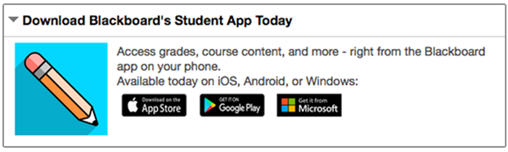

Chemistry notation support
Feature enhancement for all users
Chemistry tools, like an embedded periodic table of elements, are now included in the math editor found in the Content Editor.
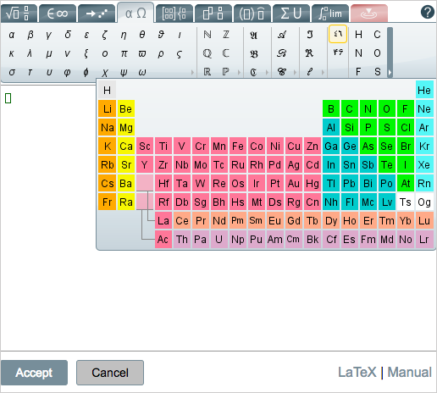

Collaborate with the Ultra experience sessions for groups [Note: Delete if you do not license Collaborate]
Feature enhancement for all users
Improve collaboration amongst student groups doing group work with the addition of Collaborate sessions to Group pages. Collaborate sessions offer real-time, face-to-face web conferencing, content sharing, and whiteboard functionality.

Course availability status
Feature enhancement for instructors
From the main course view, you can now easily see an open or closed padlock icon representing the availability of the course to students and quickly change the availability with one click, saving both time and effort. This new feature can be seen below, next to tools such as Student Preview and the Edit Mode toggle.
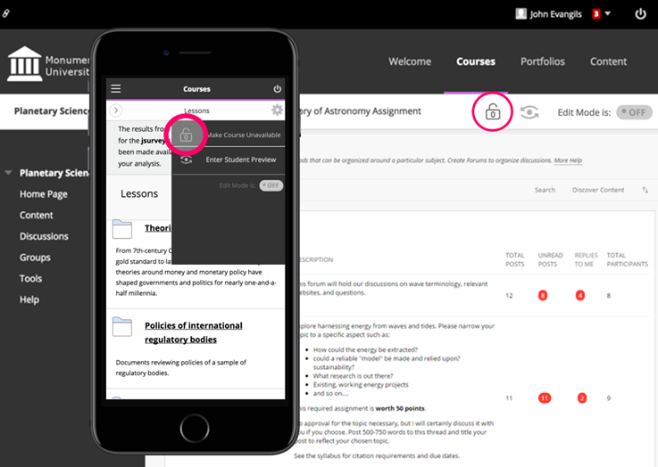

Delete multiple gradebook columns
Feature enhancement for instructors
The #1 requested feature voted by clients on the Community Site, you can now delete multiple gradebook columns at once making managing the gradebook even easier. When deleted, manual and calculated columns are removed completely; columns associated with gradable items are cleared of attempt and grade data, but remain in the Grade Center.
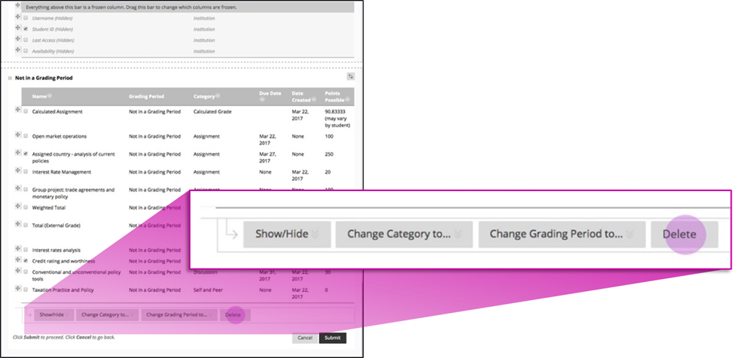

Discussion board “replies to me”
Feature enhancement for all users
Keeping up with large discussion board forums is made easier with the addition of a “Replies to me” count and filter so unread replies to your own posts can be easily identified and read.
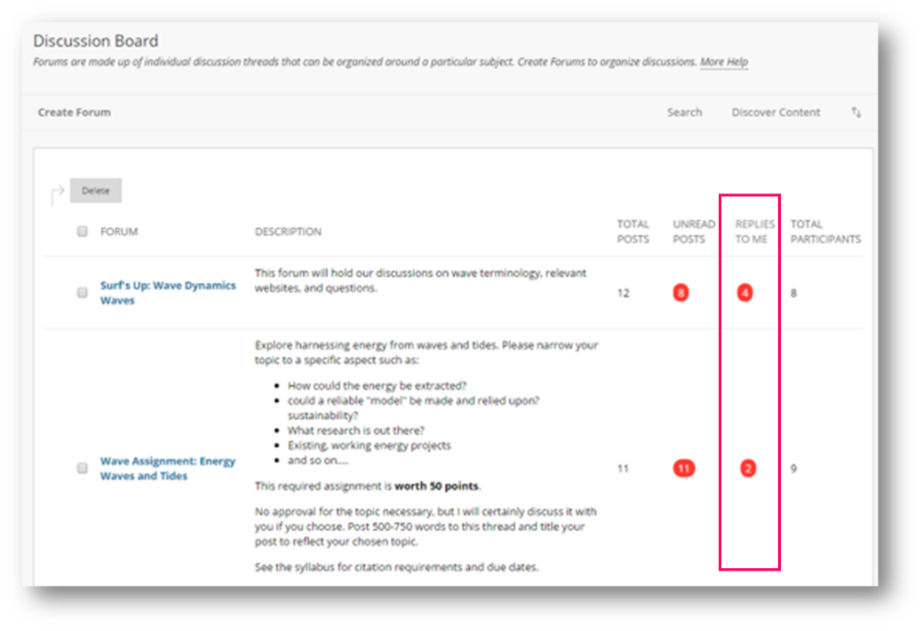

Enhanced mobile experience for Blogs and Journals
Feature enhancement for all users
You will now have a much-improved experience using Blogs and Journals on your mobile device. For example, options for filtering posts or navigating groups or users will appear below currently viewed posts.

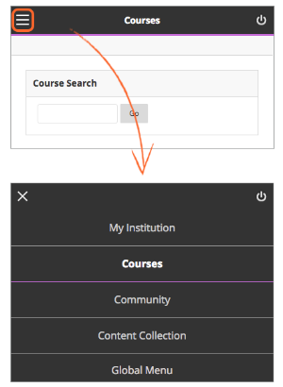
Enhanced mobile experience for navigating Learn
Feature enhancement for all users
It is now much easier to navigate the system and course menus on mobile devices. When you access Blackboard Learn through mobile devices, you’ll notice that the navigation has been moved to a hamburger menu that remains there when you move from screen to screen. Tabs and subtabs now appear in your navigation choices. My Blackboard has also been incorporated into the system menu for easier access. Within a course, the menu opens and closes more easily, improving the overall experience.

Grade display standardization
Feature enhancement for instructors
To provide greater consistency and standardization, all gradebook columns (online and downloads) and My Grades now support up to five decimal points, are not rounded, and are consistent for all display types (score, percentage, letter grade).

Improved grading with rubrics
Feature enhancement for instructors
When grading with rubrics, you can now save feedback and the content will remain saved when changing the rubric's view from in-line to full screen.

Learning Tools Interoperability (LTI) deep linking [Note: This section requires editing.]
Feature enhancement for all users
You will now have a more seamless experience when linking or integrating with tools like [Note: enter the names of some tool providers your institution / your instructors use who support the LTI deep linking specification]. You can create links to specific resources without knowing and specifying resource IDs. Instead, you can launch into the tool provider’s user experience, select resources to add to your course, and the individual links are created in the correct place in the course. Students clicking the links will be taken directly to the specific resource rather than to a generic tool page.
____________________________________________________

Blackboard Learn Q2 2017 Enhancements

Additional drag-and-drop locations
Feature enhancement for all users
The drag-and-drop feature is now added to the content editor, blog, journal, and portfolios. If the browser allows, you can drag a folder of files and the files will upload individually.

Blackboard Ally, a solution for better accessibility Note: Delete if you do not license Ally.
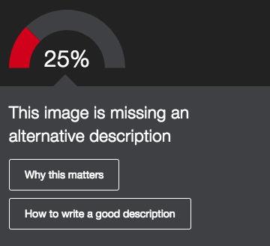
Feature enhancement for all users
Ally is a new service for improving content accessibility that has been integrated into Learn. Ally improves accessibility within Learn in the following ways:
- Instructors can view an accessibility score and learn ways to improve the accessibility of materials.
- Students can download automatically-generated alternative versions of uploaded files, such as accessible HTML, digital braille, and audio format files.

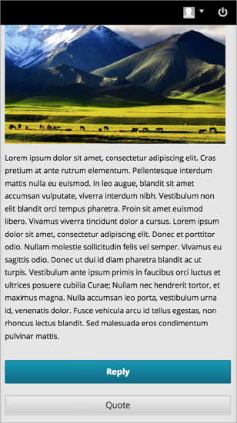
Continued mobile optimization Note: Delete if you do not have the Learn 2016 Theme enabled.
Feature enhancement for all users
The discussion board is now responsive for mobile devices if the post contents are responsive. That means you will be able to easily read, respond, and use other discussion features such as post rating when using your mobile device – and the experience will be a great one!
Additionally, pages with tables, the course menu, and within My Blackboard are better optimized for mobile devices. Contextual menus can also be accessed on both tablet and mobile devices.

Submission receipt enhancements
Feature enhancement for all users
Students can receive a notification email for each assignment attempt with information about the submission, including attached files. Students can also access receipts at any time on the My Grades page in the submissions filter area.

Blackboard Learn Q4 2016 Enhancements

A new look & feel with an improved mobile experience Note: Delete if you do not have the Learn 2016 Theme enabled.
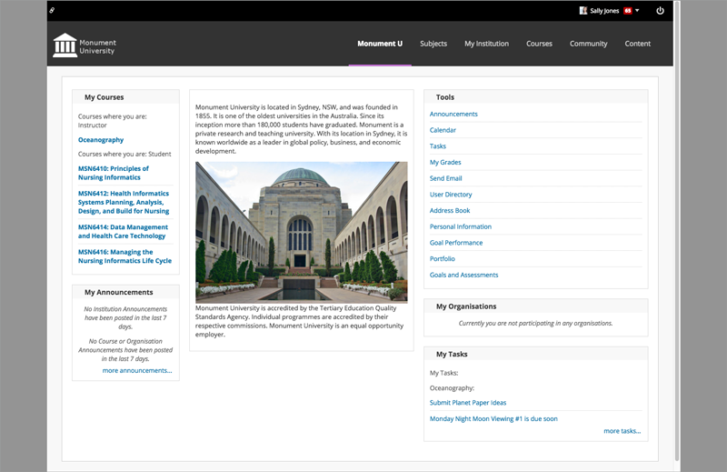
Feature enhancement for all users
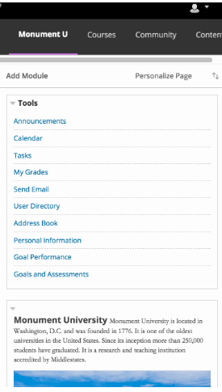
You will notice a new, more modern look and feel that enhances your Learn experience. This look and feel consists of updated colors, fonts, and spacing for greater consistency between Blackboard Learn, Collaborate with the Ultra experience, and the Blackboard mobile apps. Additionally, you’ll see an increase in the responsiveness of the interface on tablet and mobile devices, which means you will have a much improved, enjoyable mobile experience.

Course activity reports
Feature enhancement for instructors
The Course Activity Overview report has been updated to improve the experience for larger enrollment courses. Instructors can filter the report and break down the calculations of student activity by course groups.

Drag and drop files
Feature enhancement for all users
When instructors create content items, assignments, and web links, they can drag files from their computers to the "hot spot" in the Attach Files area. Students can also drag files to upload when they submit assignments. If the browser allows, users can drag a folder of files and the files will upload individually.
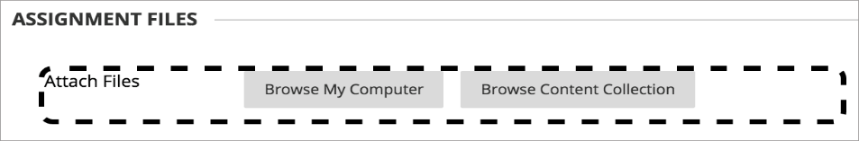

Dropbox Education Integration
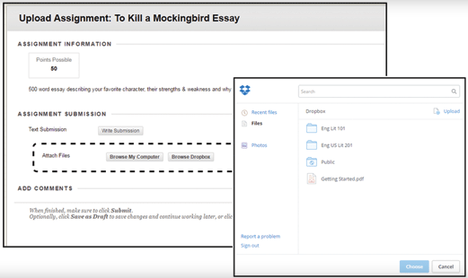
Feature enhancement for all users
Using this new cloud service integration, instructors and students can link to their Dropbox content directly from Blackboard Learn using the mashup menu found in most content creation workflows: content creation, tests, discussion boards, blogs, journals, wikis, announcements, feedback, and grading notes.

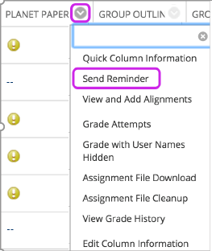
Missing coursework reminders
Feature enhancement for all users
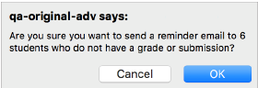
Instructors can send email reminders from Grade Center columns to students and members of groups who have missing coursework. Students receive a system-generated email that lists the course, coursework, and the due date if included. Instructors can also send reminders for assignments with anonymous or delegated grading enabled. To protect anonymity, students' names and attempt statuses aren't revealed.

Grading improvements
Feature enhancement for instructors
When multiple-attempt assessments are set to calculate using the first or last attempt, there are potentially numerous other attempts that will never be used for the grade calculation. This can be particularly problematic in anonymous or delegated grading scenarios where it can be difficult to determine which attempts are associated with students and therefore require grading. A new filter is now available both in the Needs Grading workflow as well as within the Grade Center to show or hide these attempts. Attempts that won't calculate towards the assessment grade are now indicated with an icon.
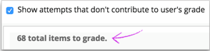
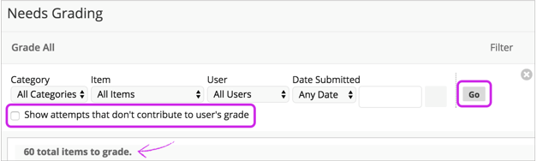

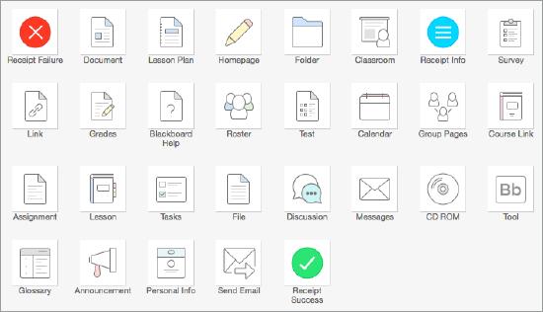
New icon set
Feature enhancement for all users
There is a new icon set for use in Courses and Organizations. Also, cancel/submit buttons will always pin to the bottom of the page regardless of device, ensuring they are easy to access.

Self and peer assessments improvements
Feature enhancement for instructors
Non-participants during the submission period are excluded from the evaluation process. Submitters with partial or complete submissions will be distributed to peers for evaluations. By pairing an assessment with Adaptive Release, it's possible to configure Self and Peer Assessments for individual groups.

Submission receipts
Feature enhancement for all users
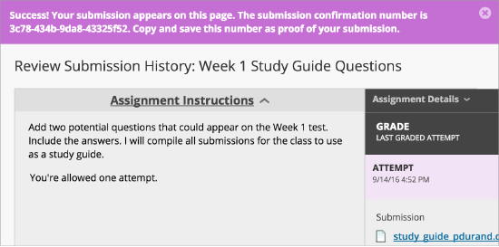
Instructors can keep track of all student submissions, regardless of whether the attempt or assignment is deleted or the submission history is changed. A submission receipt is captured at the time of submission and includes information such as attached file information, date, time, etc. This feature gives students assurance about their work and provides evidence for academic disputes.
A receipt is generated for each group member when a student submits on behalf of the group, and the anonymous state of an assignment is respected. For assignments with multiple attempts, students receive a different number for each submission.
____________________________________________________

Blackboard Learn Q2 2016 Enhancements

Accessibility updates
Feature enhancement for all users
The screen reader will not announce Quick Links modal when modal is closed, and Grading Journals will now work with a screen reader.

MOSAIC and O*NET Standards
Feature enhancement for instructors
For institutions who wish to evaluate student work or align their curriculum against either the Multipurpose Occupational Systems Analysis Inventory - Close-Ended (MOSAIC) or Occupational Information Network (O*NET) competencies, we have made these competencies available now for download on Behind the Blackboard.

VALUE rubrics
Feature enhancement for instructors
As part of the Association of American Colleges & Universities' (AAC&U’s) Liberal Education and America’s Promise (LEAP) initiative, the VALUE rubrics contribute to the national dialogue on assessment of college student learning. Educational professionals from over 100 higher education institutions collaboratively developed 16 VALUE rubrics to use the most frequently identified characteristics for measuring success in key learning outcomes.
For Blackboard Learn users who are interested in using these rubrics, we are making them available for download and import. Each rubric has been built and formatted appropriately so it can be imported to your courses and used anywhere you can align and evaluate with rubrics today. The downloadable rubrics are available in US English only, because this is how they were authored by AAC&U.
____________________________________________________

Additional Resources

Blackboard Help Site
- Blackboard's help site is your one-stop-shop to find product documentation for Blackboard products, including Blackboard Learn. This site allows anyone to view help documentation (students, instructors, or administrators), while adaptive search and tagging help you find what you’re looking for. Check it out here:
  - https://en-us.help.blackboard.com/

Blackboard Community Site
- The Blackboard community is the largest organized network of e-learning users. Join the conversation with other educators here:
  - https://community.blackboard.com/community/questions/educator
- Make sure that your ideas about our products and the future of teaching and learning are heard loud and clear by peers and Blackboard staff here:
  - https://community.blackboard.com/community/ideasmain
- Check out the Blackboard Innovative Teaching Series (BITS) hosted by Blackboard’s community of users and product experts to hear strategies and best practices for increasing efficiency and improving learning outcomes. You can register for live webinars or watch recordings of past webinars here:
  - https://community.blackboard.com/groups/higheredbits

