Google Single sign-in

Help for Administrators

Google sign-in

Allow users to sign-in with their GoogleTM login information. To do this, turn Google sign-in on and make sure user accounts are associated with their Google email address.

Allow users to use Google sign-in
- From the Site Manager, expand CONFIGURE and select Integration.
- Check the Google under Signin Providers.
- Select Save.
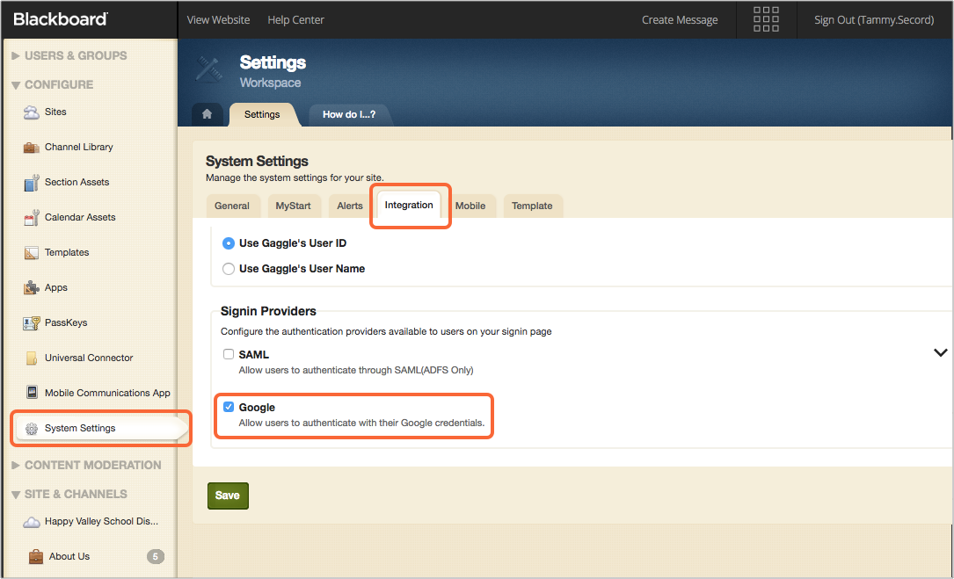

Associate Google email address with users
Before a user can sign-in with their Google account, their user account must be associated with their Google email address. You can do this when you create or update user accounts directly on the Web Community Manager (WCM) or in your Student Information System (SIS).

Each user account can have only one unique email address associated with it. The Google email addresses can use school domains if you have that set up in Google.

Important: If users are having trouble authenticating with their Google account, confirm each account has a unique Google email address associated with it.

- More on creating and editing user accounts

Google authentication process
When you select Sign in with Google, the Google Account sign-in page appears. Type your Email or Phone number and select Next. Provide your password and select Next to sign in with Google.

If the login information is correct, the Google API passes the email, basic user profile information and a Google ID to the Blackboard Web Community Manager (WCM). If this is your first time signing in using Google, Blackboard verifies that the email address is associated to a user account. If it is, we save your Google ID and log you into the Blackboard product.

Note: The basic user profile information includes the user’s first and last name, email, image, and locale.

If we can’t find the Google email in a Blackboard user account, you can’t log in with your Google account. Contact your school if you think you should be able to log in with your Google account.

The next time you sign in with your Google account, Google API passes the email and Google ID to the WCM. Since the Google ID is already stored, you are authenticated and log into the Blackboard product without having to recheck the email address connection.

Help for Parent/Student/Teacher Roles

Sign in
If you are registered user, you can sign-in to see details specific to you.

- From the website, select Sign In.
- Type your username and password. This is provided by the school.
- Select Sign In.

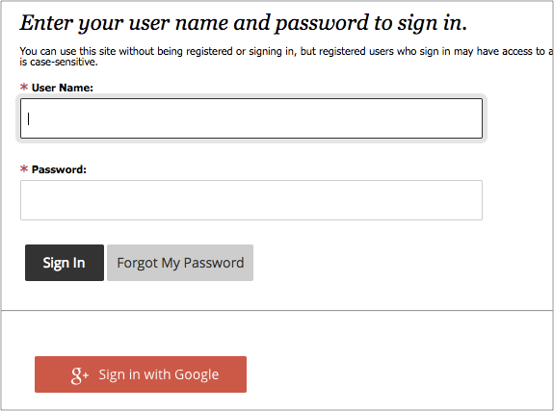

Sign in with Google
If your school has turned it on, you can sign in with your GoogleTM account. This means one less username and password to remember.

- If available, select Sign in with Google.
- Provide your Google email address and select Next.
- Provide your Google password and select Next to sign in with Google.

What information does Google share with Blackboard?
Google sends a Google ID, basic profile information, and your Google email address to Blackboard to enable you to sign in to your Web Community Manager account. The basic profile information includes your first and last name, email, image, and locale (region and language).
No other personal information is shared and your Google account remains secure.

Blackboard does not share any information with Google and your Blackboard account remains secure.

