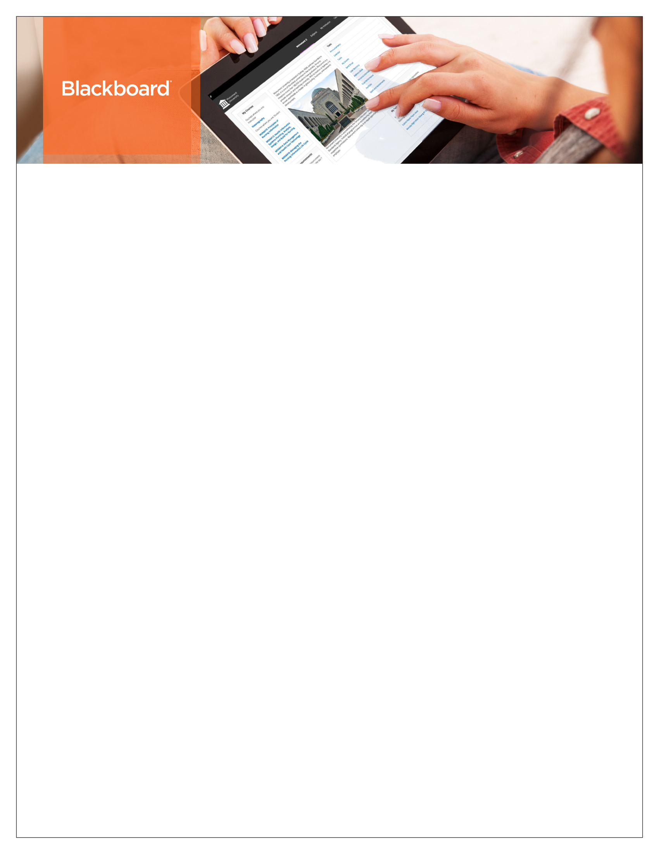

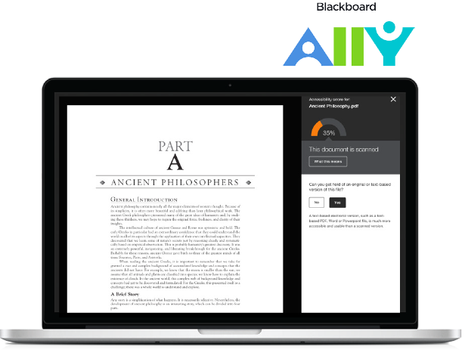

The latest releases for the Original experience of Blackboard Learn include many new features and enhancements that:

* Save time by improving the efficiency and   
  ease of use of completing your daily tasks
* Provide a much-improved mobile experience and a new modern look & feel
* Improve the accessibility of both content   
  and Learn functionality
* Simplify and enhance the assessment and   
  grading capabilities

The following new features and enhancements were made available in the most recent releases of Learn.

Efficiency & Ease of Use

* Drag and drop files – You can now quickly and easily drag and drop files from your desktop to the “hot spot” in the Attach Files area to upload them. Students can also drag and drop files to upload when they submit assignments.
* Dropbox integration – Using this new cloud service integration, you and your students can link to your Dropbox content directly from Learn using the mashup menu found in most content creation workflows.
* Course activity report enhancement – To help simplify the management of large enrollment courses, this report can now be filtered to break down the calculations of student activity by course groups.
* Discussion board thread to thread navigation You and your students can navigate from thread to thread without having to return to the main Discussions page. This improvement will save you time by reducing the number of clicks.

User Experience (Mobility & Accessibility)

* New, modern look & feel with an improved mobile experience – A new theme modernizes the overall look and feel of Learn with updated colors, fonts, and spacing. Plus, the new theme optimizes Learn for mobile devices providing a much improved, more enjoyable mobile experience.
* Blackboard Ally, a solution for better accessibility Greatly improve the accessibility of your content with this new service for Learn. Ally provides you an accessibility score for your content and suggests ways to improve the accessibility of materials. Ally also automatically generates alternative versions of your uploaded files, such as accessible HTML, digital braille, and audio format files.
* Additional accessibility enhancements Discussion boards, assessments, grading journals, and the content editor have all been enhanced to improve accessibility.

Assessment & Grading

* Goal Performance Dashboard to support Competency-Based Education – You and your students can easily track progress toward competencies and learning milestones. This new dashboard complements badging, standards and goal alignment, Portfolios, and other existing Learn capabilities to support competency-based programs.
* Submission receipts – Keep track of all student submissions, regardless of whether the attempt or assignment is deleted or the submission history is changed. A submission receipt gives students assurance about their work and can provide you evidence for academic disputes.
* Missing coursework reminders – You can now send email reminders directly from Grade Center columns to students and members of groups who have missing coursework.
* Grade Center improvements – When multiple-attempt assessments are set to calculate using the first or last attempt, a new filter is available both in the Needs Grading workflow and the Grade Center to show or hide other non-counted attempts.
* MOSAIC & O*NET standards – If you’d like to evaluate student work or align your curriculum against either the Multipurpose Occupational Systems Analysis Inventory – Close-Ended (MOSAIC) or Occupational Information Network (O*NET) competencies, these are now available for download.
* VALUE rubrics – As part of the Association of American Colleges & Universities’ (AAC&U’s) Liberal Education and America’s Promise (LEAP) initiative, VALUE rubrics contribute to the national dialogue on assessment of college student learning. Each rubric has been built and formatted appropriately so it can be easily imported to your courses.

**CHECK OUT WHAT’S NEW FOR BLACKBOARD LEARN**

Overview of the newest features and enhancements



**Blackboard.com**

* 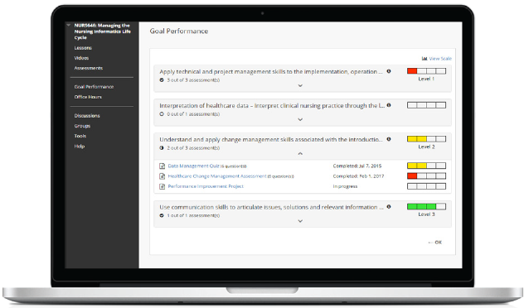

For more details on the contents of each release, see the   
Release Notes on [help.blackboard.com](https://help.blackboard.com/Learn/Administrator/Hosting/Release_Notes). Plus, provide your product suggestions and vote on ideas for our upcoming releases in the [Blackboard Idea Exchange](https://community.blackboard.com/community/ideasmain).

For more details on the contents of each release, see the   
Release Notes on [help.blackboard.com](https://help.blackboard.com/Learn/Administrator/Hosting/Release_Notes). Plus, provide your product suggestions and vote on ideas for our upcoming releases in the [Blackboard Idea Exchange](https://community.blackboard.com/community/ideasmain).

**Blackboard.com** | 1111 19th St NW | Washington, DC 20036 | 1.800.424.9299