What’s New in Blackboard Learn: Feature Guide for End Users

Table of Contents
Introduction 3
Purpose of this Document 3
Introduction 3
Blackboard Learn Q2 2017 Enhancements 3
Additional drag-and-drop locations 3
Blackboard Ally, a solution for better accessibility 3
Continued mobile optimization 4
Submission receipt enhancements 4
Blackboard Learn Q4 2016 Enhancements 5
A new look & feel with an improved mobile experience 5
Course activity reports 5
Drag and drop files 5
Dropbox Education Integration 6
Missing coursework reminders 6
Grading improvements 6
New icon set 7
Self and peer assessments improvements 7
Submission receipts 7
Blackboard Learn Q2 2016 Enhancements 8
Accessibility updates 8
MOSAIC and O*NET Standards 8
VALUE rubrics 8
Blackboard Learn Q4 2015 Enhancements 9
Accessibility update: Assessments 9
Accessibility update: Content editor 9
Accessibility update: Discussion boards 9
Discussion threads 9
Escaping special characters 9
Grades Journey 9
Goal Performance Dashboard 10
Additional Resources 11
Blackboard Help Site 11
Blackboard Community Site 11

Introduction

Purpose of this Document
The purpose of this document is to provide educators and learners with an overview of the new features and enhancements that are part of our latest Blackboard Learn releases (Q4 2015 through Q2 2017).
We invite each institution to customize and share this document as you see fit, based on the version of Blackboard Learn you are on and the version to which you are upgrading. To make it easy for you to customize this document, we have separated the enhancements by release so you can remove the releases that do not apply to your institution’s upgrade.

Introduction
We have recently updated our Blackboard Learn environment to the latest version, which includes many new features and enhancements that will:
- Simplify and enhance many capabilities you currently use today
- Save you time and make it easier to complete your daily tasks
- Provide a much-improved mobile experience and a new modern look & feel
- Improve the accessibility of the technology as well as the content itself
This document will provide you, our educators and students, with an overview of these new features and enhancements that are now available in Blackboard Learn.

Blackboard Learn Q2 2017 Enhancements

Additional drag-and-drop locations
Feature enhancement for all users
The drag-and-drop feature is now added to the content collection, editor, blog, journal, and portfolios. If the browser allows, you can drag a folder of files and the files will upload individually.

Blackboard Ally, a solution for better accessibility
Feature enhancement for all users
Ally is a new service for improving content accessibility that has been integrated into Learn. Ally improves accessibility within Learn in the following ways:
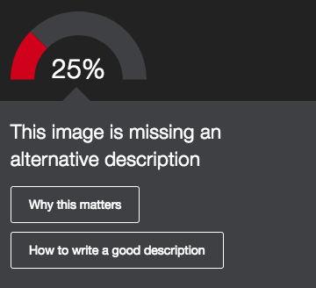
- Instructors can view an accessibility score and learn ways to improve the accessibility of materials.
- Students can download automatically-generated alternative versions of uploaded files, such as accessible HTML, digital braille, and audio format files.
Note: This is a new, optional solution for Learn. You should delete this paragraph if you do not license Ally.

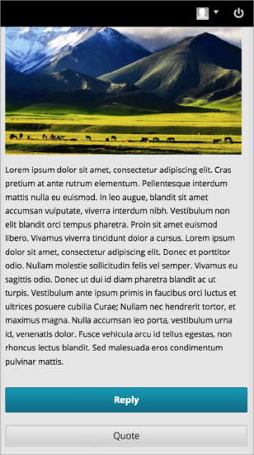
Continued mobile optimization
Feature enhancement for all users
The discussion board is now responsive for mobile devices if the post contents are responsive. That means you will be able to easily read, respond, and use other discussion features such as post rating when using your mobile device – and the experience will be a great one!
Additionally, pages with tables, the course menu, and within My Blackboard are better optimized for mobile devices. Contextual menus can also be accessed on both tablet and mobile devices.
Note: Your institution must have the Learn 2016 Theme enabled to take advantage of the enhancements discussed above. If it is not enabled, you should delete this section.

Submission receipt enhancements
Feature enhancement for all users
Students can receive a notification email for each assignment attempt with information about the submission, including attached files. Students can also access receipts at any time on the My Grades page in the submissions filter area.

Blackboard Learn Q4 2016 Enhancements

A new look & feel with an improved mobile experience
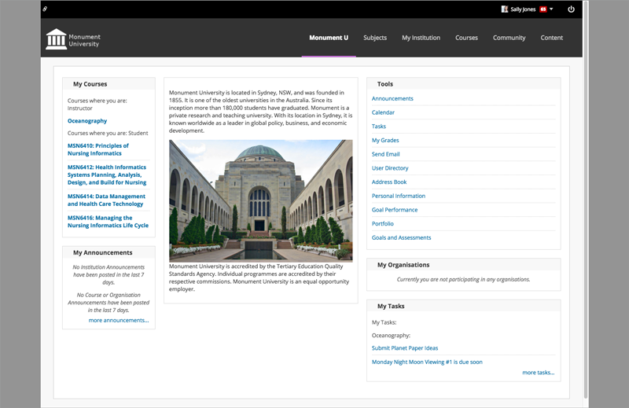
Feature enhancement for all users
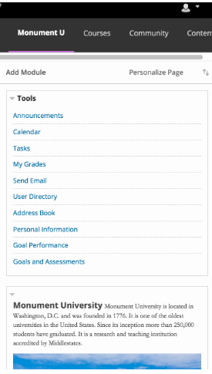
You will notice a new, more modern look and feel that enhances your Learn experience. This look and feel consists of updated colors, fonts, and spacing for greater consistency between Blackboard Learn, Collaborate with the Ultra experience, and the Blackboard mobile apps. Additionally, you’ll see an increase in the responsiveness of the interface on tablet and mobile devices, which means you will have a much improved, enjoyable mobile experience.
Note: This is dependent on the use of the Learn 2016 theme. Delete this if your institution has not enabled the Learn 2016 theme.

Course activity reports
Feature enhancement for instructors
The Course Activity Overview report has been updated to improve the experience for larger enrollment courses. Instructors can filter the report and break down the calculations of student activity by course groups.

Drag and drop files
Feature enhancement for all users
When instructors create content items, assignments, and web links, they can drag files from their computers to the "hot spot" in the Attach Files area. Students can also drag files to upload when they submit assignments. If the browser allows, users can drag a folder of files and the files will upload individually.
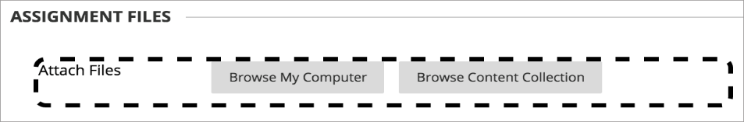

Dropbox Education Integration
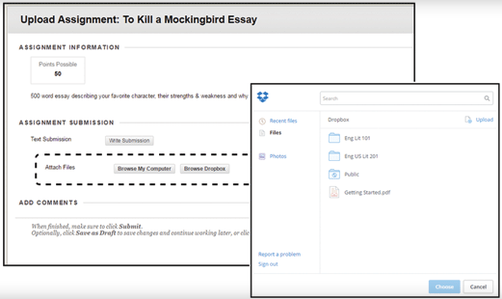
Feature enhancement for all users
Using this new cloud service integration, instructors and students can link to their Dropbox content directly from Blackboard Learn using the mashup menu found in most content creation workflows: content creation, tests, discussion boards, blogs, journals, wikis, announcements, feedback, and grading notes.

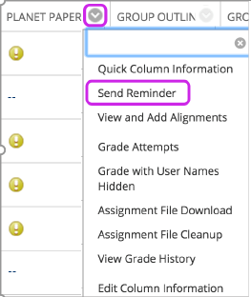
Missing coursework reminders
Feature enhancement for all users
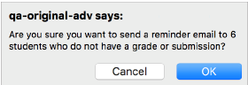
Instructors can send email reminders from Grade Center columns to students and members of groups who have missing coursework. Students receive a system-generated email that lists the course, coursework, and the due date if included. Instructors can also send reminders for assignments with anonymous or delegated grading enabled. To protect anonymity, students' names and attempt statuses aren't revealed.

Grading improvements
Feature enhancement for instructors
When multiple-attempt assessments are set to calculate using the first or last attempt, there are potentially numerous other attempts that will never be used for the grade calculation. This can be particularly problematic in anonymous or delegated grading scenarios where it can be difficult to determine which attempts are associated with students and therefore require grading. A new filter is now available both in the Needs Grading workflow as well as within the Grade Center to show or hide these attempts. Attempts that won't calculate towards the assessment grade are now indicated with an icon.
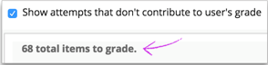
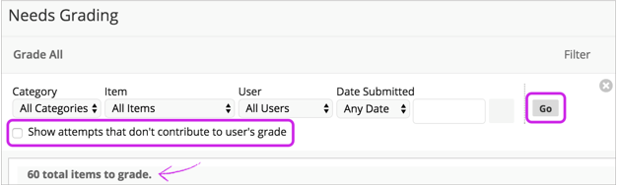

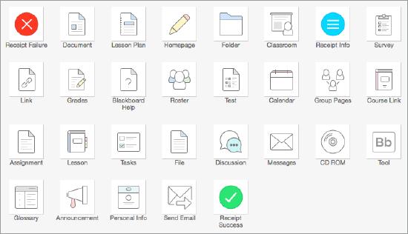
New icon set
Feature enhancement for all users
There is a new icon set for use in Courses and Organizations. Also, cancel/submit buttons will always pin to the bottom of the page regardless of device, ensuring they are easy to access.

Self and peer assessments improvements
Feature enhancement for instructors
Non-participants during the submission period are excluded from the evaluation process. Submitters with partial or complete submissions will be distributed to peers for evaluations. By pairing an assessment with Adaptive Release, it's possible to configure Self and Peer Assessments for individual groups.

Submission receipts
Feature enhancement for all users
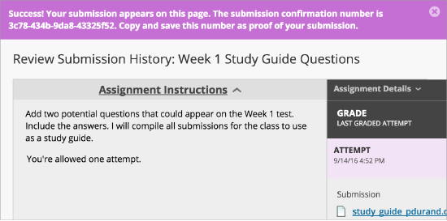
Instructors can keep track of all student submissions, regardless of whether the attempt or assignment is deleted or the submission history is changed. A submission receipt is captured at the time of submission and includes information such as attached file information, date, time, etc. This feature gives students assurance about their work and provides evidence for academic disputes.
A receipt is generated for each group member when a student submits on behalf of the group, and the anonymous state of an assignment is respected. For assignments with multiple attempts, students receive a different number for each submission.

Blackboard Learn Q2 2016 Enhancements

Accessibility updates
Feature enhancement for all users
The screen reader will not announce Quick Links modal when modal is closed, and Grading Journals will now work with a screen reader.

MOSAIC and O*NET Standards
Feature enhancement for instructors
For institutions who wish to evaluate student work or align their curriculum against either the Multipurpose Occupational Systems Analysis Inventory - Close-Ended (MOSAIC) or Occupational Information Network (O*NET) competencies, we have made these competencies available now for download on Behind the Blackboard.

VALUE rubrics
Feature enhancement for instructors
As part of the Association of American Colleges & Universities' (AAC&U’s) Liberal Education and America’s Promise (LEAP) initiative, the VALUE rubrics contribute to the national dialogue on assessment of college student learning. Educational professionals from over 100 higher education institutions collaboratively developed 16 VALUE rubrics to use the most frequently identified characteristics for measuring success in key learning outcomes.
For Blackboard Learn users who are interested in using these rubrics, we are making them available for download and import. Each rubric has been built and formatted appropriately so it can be imported to your courses and used anywhere you can align and evaluate with rubrics today. The downloadable rubrics are available in US English only, because this is how they were authored by AAC&U.

Blackboard Learn Q4 2015 Enhancements

Accessibility update: Assessments
Feature enhancement for all users
When creating a hot spot question, an Image Alternate text box is now available. This improves accessibility for users.

Accessibility update: Content editor
Feature enhancement for all users
The default heading size for all the embedded headings has been increased so they are properly read in both the view and edit state in the Content Editor.

Accessibility update: Discussion boards
Feature enhancement for all users
Forum descriptions are read on the Create Thread page. This improves accessibility for users with screen reader technologies.
Announcement date restriction default
Feature enhancement for instructors
When creating an announcement, "Not Date Restricted" is now selected by default.

Discussion threads
Feature enhancement for all users
You can navigate from thread to thread without having to return to the main Discussions page, saving you time.

Escaping special characters
Feature enhancement for all users
When you upload a file to Learn and the filename contains special characters (such as / \ : ? * " < > |), the system replaces the special character with an underscore (_).

Grades Journey
Feature enhancement for instructors
You can now automate the exchange of assignment and grade data between your student information system (SIS) and Learn. You can post your gradebook for retrieval and the SIS will retrieve submitted grades.
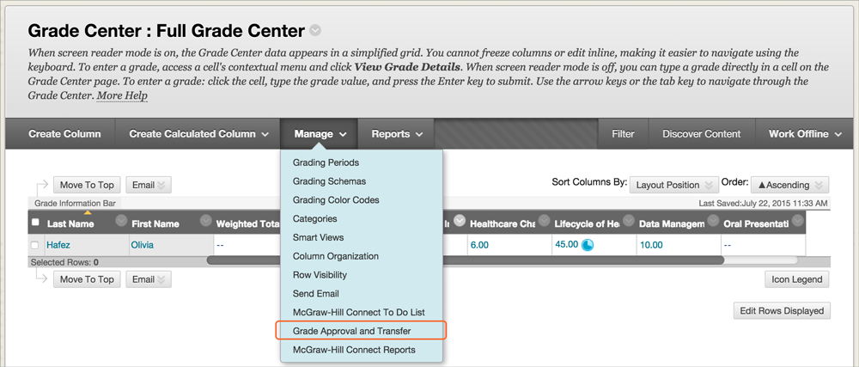

Note: Delete Grades Journey if your institution has not installed it.

Goal Performance Dashboard
Feature enhancement for all users
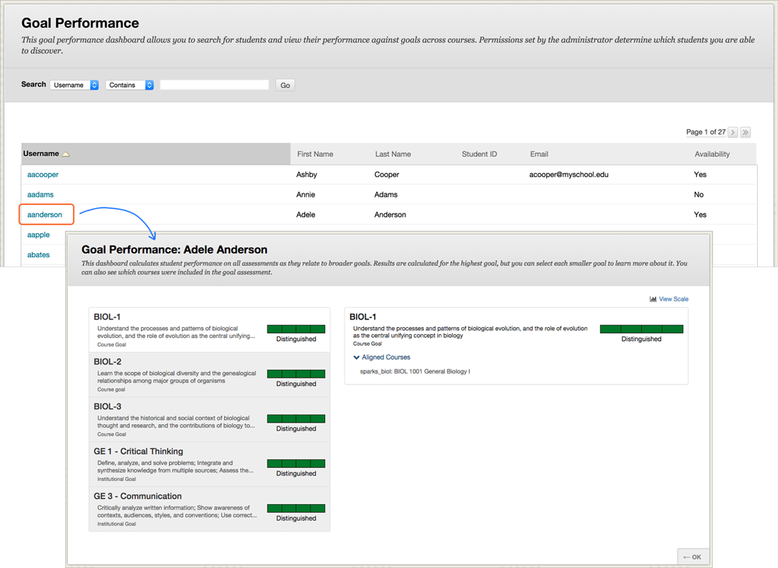
Instructors and students can easily track progress toward competencies and learning milestones. This new dashboard complements badging, standards and goal alignment, Portfolios, and other existing Learn capabilities to support competency-based programs.
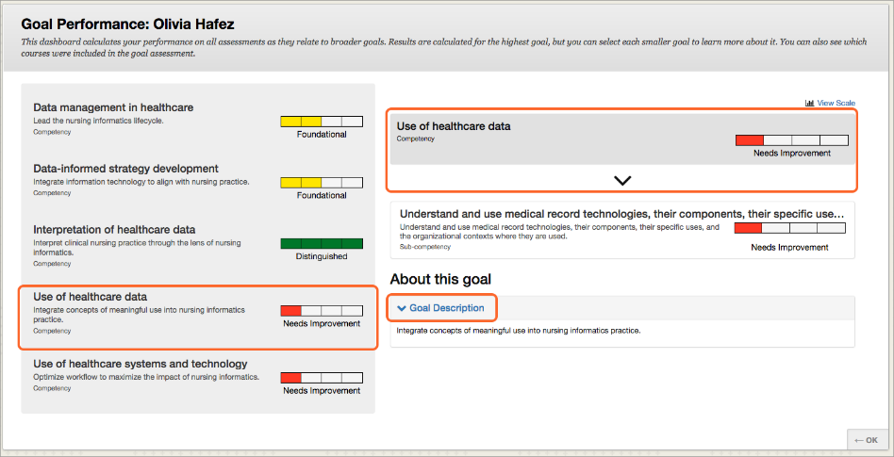

Additional Resources

Blackboard Help Site
- Blackboard's help site is your one-stop-shop to find product documentation for Blackboard products, including Blackboard Learn. This site allows anyone to view help documentation (students, instructors, or administrators), while adaptive search and tagging help you find what you’re looking for. Check it out here:
  - https://en-us.help.blackboard.com/

Blackboard Community Site
- The Blackboard community is the largest organized network of e-learning users. Join the conversation with other educators here:
  - https://community.blackboard.com/community/questions/educator
- Make sure that your ideas about our products and the future of teaching and learning are heard loud and clear by peers and Blackboard staff here:
  - https://community.blackboard.com/community/ideasmain
- Check out the Blackboard Innovative Teaching Series (BITS) hosted by Blackboard’s community of users and product experts to hear strategies and best practices for increasing efficiency and improving learning outcomes. You can register for live webinars or watch recordings of past webinars here:
  - https://community.blackboard.com/groups/higheredbits

