Emergency Message Prompts
When a Connect user sends an Emergency message, a new warning will appear on the Review your Message page to provide information on what types of messages constitute an ‘emergency’. The user needs to check the box before s/he can schedule the message.

Warning text for Emergency Message on Review your Message page - I acknowledge that the content of this message meets the criteria for an ‘emergency’.
Information icon text - In the context of the Telephone Consumer Protection Act, the FCC defines “emergency purposes” as “calls made necessary in any situation affecting the health and safety of consumers”.

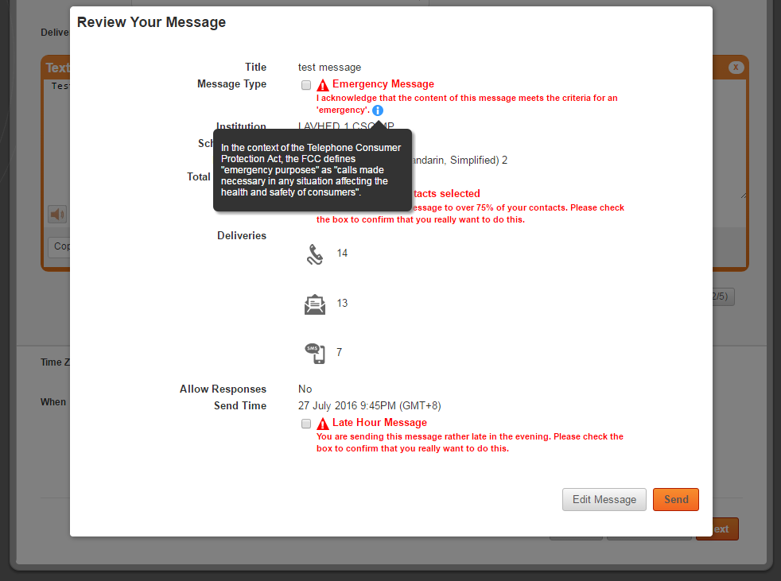

Additionally, when creating an Emergency Message template, a new warning in red text is also displayed on the Create Template page.

Warning text for Emergency Message on Create Template page - I acknowledge that this template will be used solely to create messages that meet the criteria for an ‘emergency’.
Information icon text - In the context of the Telephone Consumer Protection Act, the FCC defines “emergency purposes” as “calls made necessary in any situation affecting the health and safety of consumers”.

