Four Principles for PowerPoint Accessibility - Windows

These instructions apply to Microsoft PowerPoint 2016 for Windows. The main accessibility principles involve:
- Slide titles
- Reading order
- Alternative text for images
- Self-describing links
- Other tips

Principle One: Slide Titles
Use pre-defined PowerPoint slide templates rather than creating custom templates. These templates have Slide titles built into their structure. Slide titles provide heading structure for screen reader users.
- On the Home tab, choose layouts from the New Slide or Layouts drop-down menus and select a slide that includes a title and appropriate structural elements.
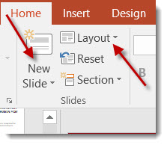

If you do not want the title to be visible on your slide, do the following:
- On the Home tab in the Drawing pane, click the Arrange menu.
- Click Selection Pane.
- Click the eye icon next to the text box to toggle its visibility.
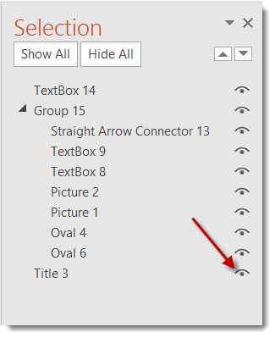

Things to consider when adding slide titles:
- Each slide should have either a visible or non-visible slide title.
- Use unique heading titles for each slide. If multiple slides refer to the same topic, consider adding “continued” to the end of the slide title or hiding its visibility.

Principle Two: Reading Order
- On the Home tab and in the Drawing pane, click Arrange; then choose Selection Panel.
- The Selection Panel lists the objects on the slide. Objects will be read back beginning with the bottom list item and ending with the top list item. Use the arrows to re-order the objects.
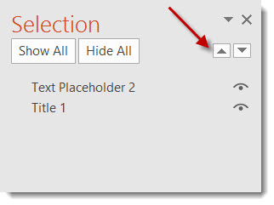
- On the View tab, select Outline in the Presentation Views group. Check the reading order and look for text included on the slide, but not in the outline. 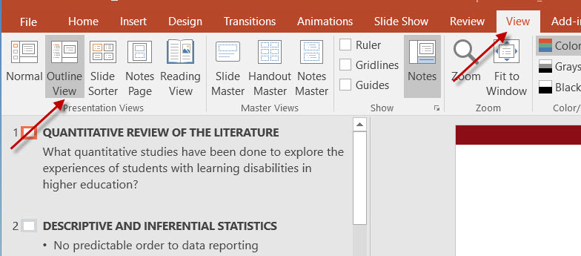

- Text added in text boxes may not appear in the Outline View. This text can be copied and pasted into the Outline View.
- Conversely, slide titles that have been visibly hidden should still appear as text in the Outline View.

Things to consider when setting reading order:
- Make sure your reading order is logical.
- PowerPoint’s built-in templates have pre-defined reading order. Slides created from a blank slide will likely require you to manually set the reading order.

Principle Three: Alternative Text for Images
- Right-click the image, and select Format Picture.
- Select the third Size and Properties icon and then drop down Alt Text area.
- In the Title and Description fields, enter the same alternative text for the image. The alternative text should present the meaning or purpose of the image rather than a literal description of its appearance.
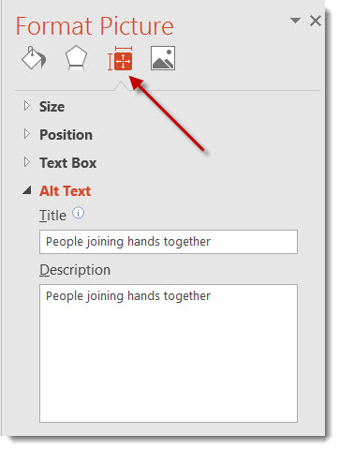

Things to consider when providing ALT Text for images:
- You do not need to include “image of” or “picture of” in the description.
- Any text within the image must be included in the Alt Text.
- Keep Alt Text succinct and discuss the image during the actual presentation.
- In PowerPoint, all images must have alternative text, even if they are purely decorative.
- Be concise with your use of images and avoid clutter.

Principle Four: Self-Describing Links
- Go to the Internet and locate the website you wish to link to. Copy the URL.
- Then highlight the text in your PowerPoint slide that you want to turn into a descriptive link.
- Right-click the text or go to the Insert tab and click on Hyperlink.
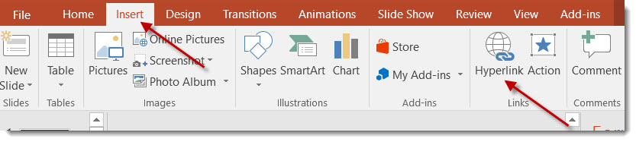
- Type or paste the URL in the Address field.
- Then click OK.
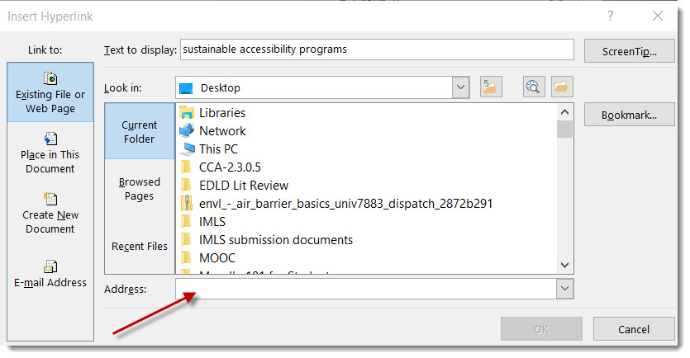

Things to consider when providing self-describing links:
- The link text should describe where the user will be taken. For example: University of Montana Homepage
- If you wish to include the URL for users who may print the slides, place the URL in parenthesis next to the self-describing link, right-click the URL, and select Remove Hyperlink. Example: University of Montana Homepage (http://www.umt.edu)

Accessibility Checker
- PowerPoint has a built-in Accessibility Checker that can usually identify issues with any of the items listed above. To use the Accessibility Checker, click File, Info, Check for Issues, Check for Accessibility. When used in conjunction with the Selection Pane, you can better insure accessibility in your PowerPoint presentation. Helpful information related to Why Fix and How to Fix is provided in the Additional Information section of the Inspection Results.
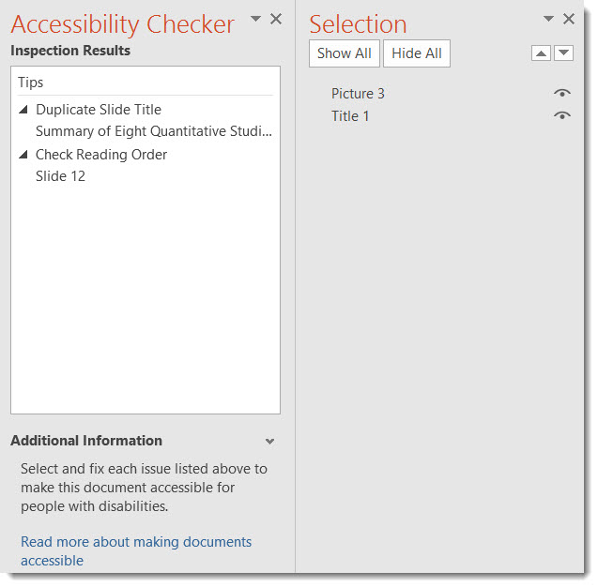

Other Accessibility Tips
- Ensure sufficient font size.
- Provide sufficient contrast between the text and the background.
- Do not use color as the only way to convey information.
- Navigating tables in PowerPoint is difficult for assistive technology users; consider providing table data in an Excel or Word file, separate from the PowerPoint slideshow, or provide the data in a list format.
- Player controls for videos embedded in PowerPoint are currently inaccessible; consider adding a self-describing link to the video on YouTube/Vimeo or provide the video file separately from the PowerPoint slideshow. Ensure the video is captioned.
- Audio files should include a transcript.
- Users may interact with PowerPoint files in various ways; provide the PowerPoint file itself instead of a PDF to allow for these various techniques.

